ARTS IMPACT LESSON PLAN
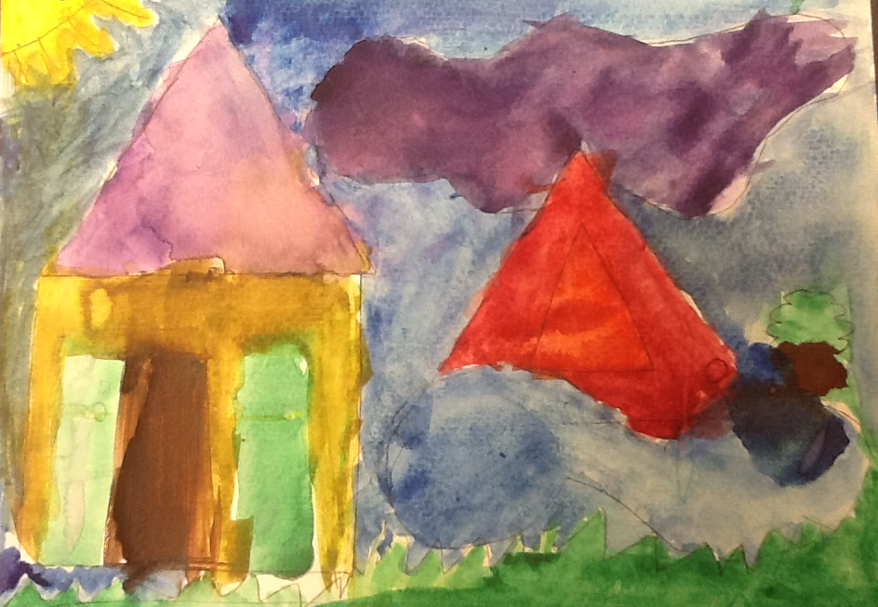
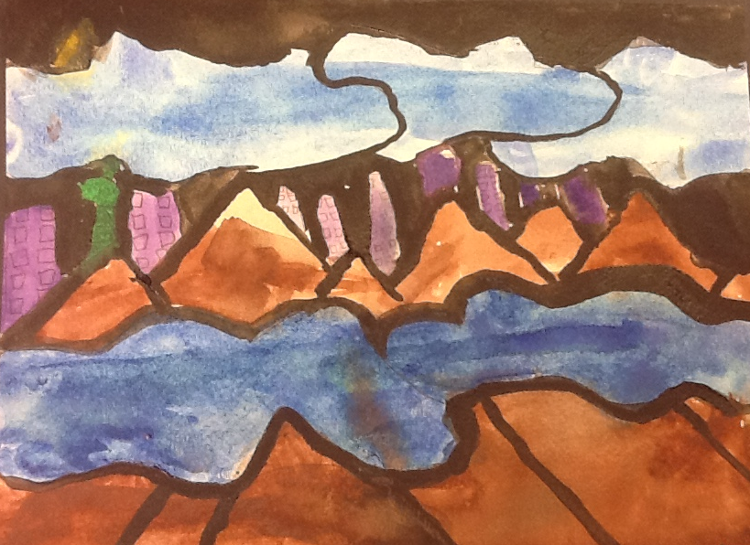
Visual Arts Lesson

Shapes in the World
Authors: Barbra Zambrano with Carol Gould
Grade Level: 2nd grade

Enduring Understanding
Organic and geometric shapes can be combined to create natural and constructed elements in a landscape.

Lesson Description(Use for family communication and displaying student art)
Students identify attributes of geometric and organic shapes in order to understand that by combining these two, they can represent a landscape. Students draw shapes and cut them out to use as templates as the basis for their water color landscape.
Learning Targets and Assessment Criteria
Target: Identifies and makes geometric shapes.
Criteria: Discusses the attributes of, draws, and cuts out geometric shapes.

Target: Identifies and makes organic shapes.
Criteria: Discusses the attributes of, draws, and cuts out organic shapes.

Target: Recognizes attributes of shapes in art.
Criteria: Compares and describes organic and geometric shapes on a graphic organizer.

Target: Creates a landscape painting combining geometric and organic shapes.
Criteria: Combines geometric shapes to represent a manmade structure and/or organic shapes to
represent natural elements in a picture of a place (landscape), and adds watercolor.
Materials
Museum Artworks or Performance
Tacoma Art Museum:
Bertha Lum 1879-1954 Untitled (Yellow Lanterns), 1913. Woodblock print

Seattle Art Museum:
Cleveland Rockwell, Smokey Sunrise Astoria Harbor. 1882, 89.7

Mark Tobey, Farmer’s Market, 1941, 42.31

Alexander Calder, The Eagle, 1971, 2000.69

Materials
Graphic organizers, Pencils, Rulers, Compasses, Scissors
Newsprint, Card stock or file folders
Watercolor paper (9 X 12), Water color paints, Brushes
Assessment checklist

Vocabulary
Arts:
Geometric shape
Landscape
Organic shape
Shape
Template

Learning Standards
WA Arts State Grade Level Expectations
For the full description of each WA State Arts Grade Level Expectation, see:http://www.k12.wa.us/Arts/Standards
1.1.2 Elements: Shape
1.1.5 Elements: Space
1.2.1 Skills and Techniques: Shape Drawing; Watercolor Painting
2.1.1 Creative Process
2.3.1 Responding Process
4.2.1 Connection between Visual Arts and Math

Early Learning Guidelines, if applicable
For a full description of Washington State Early Learning and Child Development Guidelines see: http://www.k12.wa.us/EarlyLearning/guidelines.aspx
(2nd Grade) 5. Communicating: Take part in conversations by linking his or her comments to the remarks of others, and asking and answering questions to gather additional information or deepen understanding of a topic.

Pre-Teach
ICON KEY:

= Indicates note or reminder for teacher

= Embedded assessment points in the lesson

Introduce organic and geometric shapes. Define landscape and share photo or illustration examples of landscapes. Practice using the tools and materials of watercolor painting.
Lesson Steps Outline
1. Review knowledge of geometric and organic shapes. Guide peer and class discussion of shapes in response to demonstration and works of art.
Have students say: This is an organic shape because_______ and it represents the ____________. This is a geometric shape because __________ and it represents the____________.

Model how to add geometric and organic shapes and what they represent in the painting they just observed. Students return to desk to fill out chart observing a different work of art.

Criteria-based teacher checklist and exit ticket: Discusses the attributes of geometric and organic shapes. Compares and describes organic and geometric shapes on a graphic organizer.

2. Demonstrate and guide drawing and cutting out shape templates.
Students return to their desk and draw and cut out two organic and two geometric shape templates. Student can share their templates as they create their landscapes.

Criteria-based teacher checklist: Draws, and cuts out geometric shapes and draws and cuts out organic shapes.

3. Demonstrate and guide drawing landscape shapes with pencil using the templates.

Under the document camera show students how you put the templates together, separate them or put them at different levels before deciding the real life landscape they are going to draw.

Model how to use organic or other templates to draw different parts of the landscape and model how to trace them.

Criteria-based teacher checklist: Combines geometric shapes to represent a manmade structure and/or organic shapes to represent natural elements in a picture of a place (landscape).

4. Demonstrate and guide painting landscape with water color. Model for students how to use the pencils and the water colors under the document camera.

Criteria-based teacher checklist: Adds watercolor.

5. Guide student criteria-based reflection. Display paintings and have students point out use of organic and geometric shapes in their own or someone else’s work.

Criteria-based group reflection: Reflects on and responds to art.

LESSON STEPS____________________________________________
1. Review knowledge of geometric and organic shapes. Guide peer and class discussion of shapes in response to demonstration and works of art.
Teacher writes answers on poster.

- Who can tell me the name of different geometric shapes? Now that we know some of the shapes, what can you tell me about the attributes of these shapes.

Teacher chooses painting from list of SAM artworks.

- Now I am going to show you a painting and I want you to take a close look and tell me if you can identify some of the geometric shapes you just mentioned in this painting.

Have students discuss the different geometric shapes they see with another partner. Then bring them together to have a whole class discussion.

- Can someone share what were the different shapes they saw in the painting? (Have different students share out. Ask if anybody agrees or disagrees)

- Now I have a question: What about all these different shapes (point to organic shapes in the painting) that I see here? Is that a triangle or a rectangular shape? (have students answer)

- These are also shapes. (grab a ruler, then draw a dot on the board or poster, continue to draw a triangle with using the ruler as you say) Remember that a shape is any line that meets itself. (Next to it repeat the definition of shape)

- But it can also be a line that meets itself (start with a dot and continue with an organic shape)
they are not call geometric, they do not have attributes that are always the same. They are called organic shapes, they do not have established names or forms. (Show them the same or another painting from the list so students can now identify the organic and the geometric shapes)

- I want you to take another look at this painting and I want you to discuss with your partner the different shapes you see.

Have students say:

This is an organic shape because_______ and it represents the ____________.

This is a geometric shape because __________ and it represents the____________.

- I hear great discussions about the different shapes you see in this painting. Can you share them out with the rest of the class? Here you have this graphic organizer that you will be filling out but first I am going to show you how to.

Model how to add geometric and organic shapes and what they represent in the artwork they just observed.

Students return to desk to fill out chart observing a different work of art.

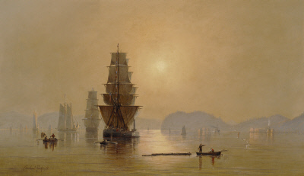

Cleveland Rockwell.
Smokey Sunrise Astoria Harbor. 1882

Mark Tobey, Farmer’s Market, 1941

Alexander Calder, The Eagle, 1971
Olympic Sculpture park

Bertha Lum 1879-1954 Untitled (Yellow Lanterns), 1913

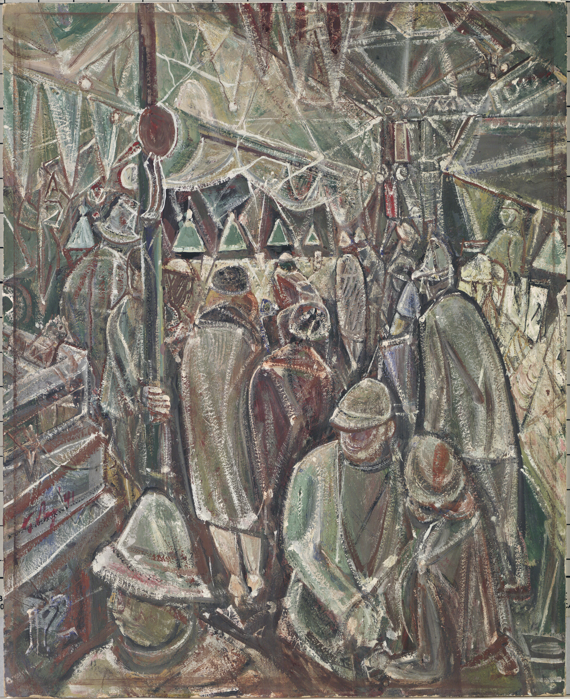
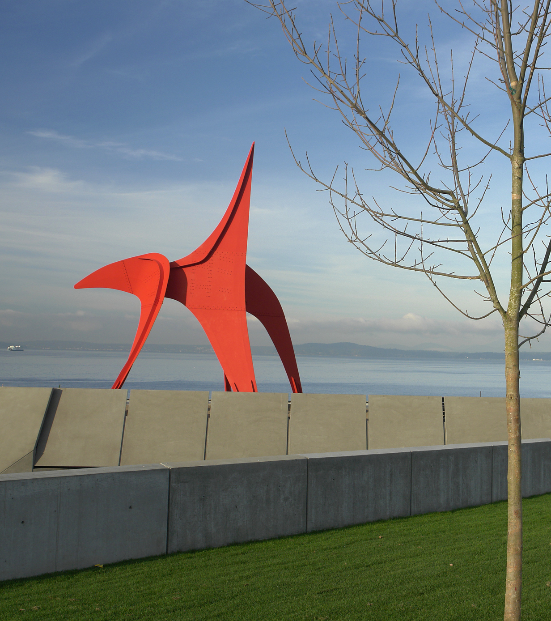

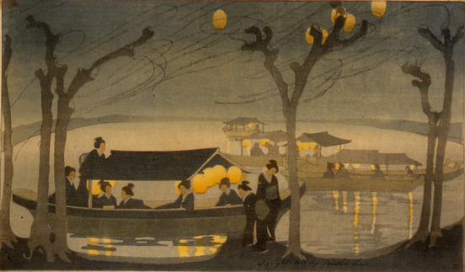

Project any of the artworks in the list and leave it up as students work on their graphic organizer.

Criteria-based teacher checklist and exit ticket: Discusses the attributes of geometric and organic shapes. Compares and describes organic and geometric shapes on a graphic organizer.
_______________________________________________________________________

2. Demonstrate and guide drawing and cutting out shape templates.

- Now you are going to be the artist and are going to create your own landscape using organic and geometric shapes.

- Here are the rulers and compasses for you to draw and cut out geometric shape templates.

Teacher could provide additional templates like different size triangles and circles.

- For organic shapes you need only the pencil.

- Watch as I draw my shapes as big as my hand on the card stock.

- When you draw geometric shapes, push hard to keep your ruler from slipping.

- When you cut, go slow, open up your scissors wide, and turn the paper as you cut, not the scissors.

Students return to their desk and draw and cut out two organic and two geometric shape templates. Student can share their templates as they create their landscapes.

- Make sure the two geometric and two organic shape templates have your initials.

Criteria-based teacher checklist: Draws and cuts out geometric shapes and draws and cuts out organic shapes.
_______________________________________________________________________

3. Demonstrate and guide drawing landscape shapes with pencil using the templates.

- Artists, now I am going to show you how I am going to use my templates to create my landscape. Remember that you can use your templates and also you can share the templates with your table partners, to make a beautiful landscape like the ones in the paintings you saw.

- First, I am going to grab my templates and I will play around with them. I will put them together, I will separate them, put them at different levels and I am going to visualize different real life objects that I can draw.

Under the document camera show students how you put the templates together, separate them or put them at different levels before deciding the real life landscape they are going to draw.

- Once you have decided what geometric object/structure you want to draw, with a pencil, trace the outlines using your geometric template.

Model how to use organic or other templates to draw different parts of the landscape and model how to trace them.

- Continue using the same or other templates until you finish your landscape.

Criteria-based teacher checklist: Combines geometric shapes to represent a manmade structure and/or organic shapes to represent natural elements in a picture of a place (landscape).
_______________________________________________________________________

4. Demonstrate and guide painting landscape with water color. Model for students how to use the pencils and the water colors under the document camera.

- Ok painters, now that you have finished your landscape with pencils, look at me as I use the water colors to paint my landscape.

- Please add prompts used to demonstrate and guide use of brushes, palette, mixing and controlling amount of water (when you complete your final edits after teaching the lesson).

- Try, as much as possible, to stay within your shapes, so we can still see them when you add paint.

Walk around to support process while students finish.

- When you are done painting bring me your paintings so we can display them.

Criteria-based teacher checklist: Adds watercolor.
_______________________________________________________________________

5. Guide student criteria-based reflection. Display paintings and have students point out use of organic and geometric shapes in their own or someone else’s work.

- Choose a landscape painting (can be yours or a peer’s) that stands out or captures your attention.

- Describe the geometric organic shapes you see in that painting. Tell the class why you think the combination of shapes makes that painting stand out.

- Artists, look closely at all the paintings. Is there a question you have for another artist?

- Are you curious about the shapes they made and how they used them, or maybe the way they used the watercolor paint? Ask and learn.

Criteria-based group reflection: Reflects on and responds to art.
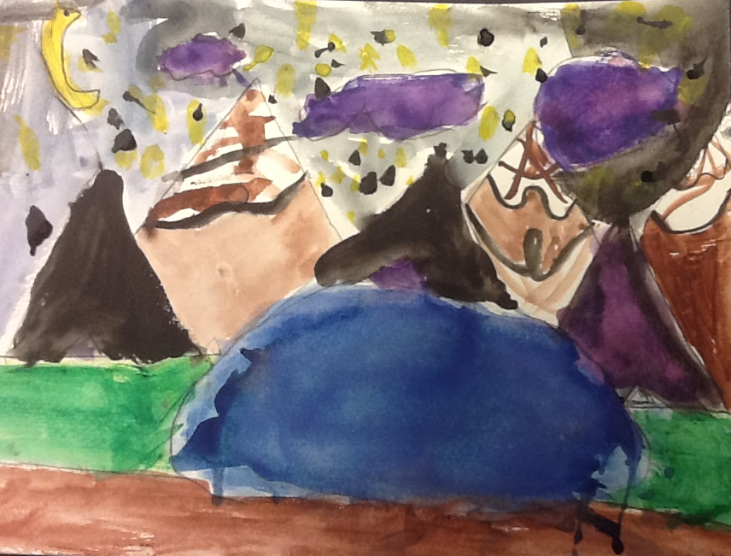
_______________________________________________________________________
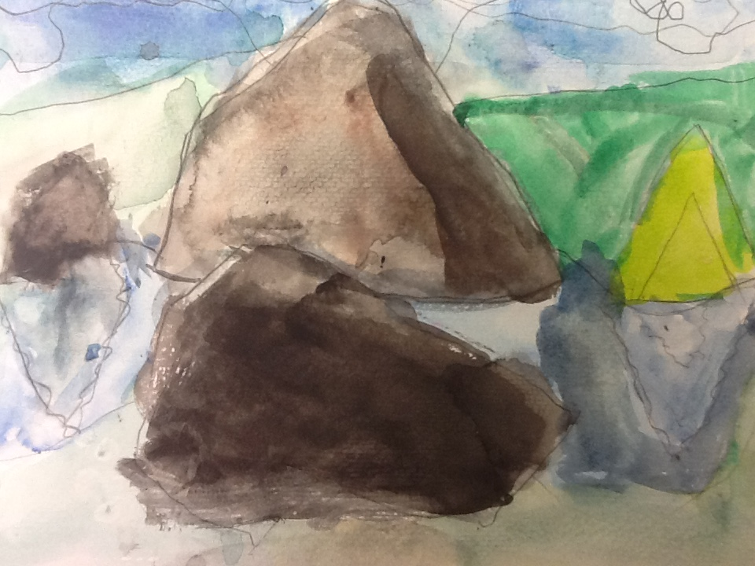

ARTS IMPACT LESSON PLAN Arts Foundations Visual Arts Lesson
2nd Grade: Shapes in the World
CLASS ASSESSMENT WORKSHEET

Disciplines | VISUAL ARTS |  |  |  |  |  |  | Total  7
Concept | Shape |  |  |  | Landscape Composition
Criteria  Student Name | Geometric |  | Organic
 | Discusses the attributes | Draws and cuts out | Discusses the attributes | Draws and cuts out | Compares and describes organic and geometric shapes on a graphic organizer. | Combines geometric shapes to represent a manmade structure and/or organic shapes to  represent natural elements in a picture of a place. | Adds Water-  color.
1.
2.
3.
4.
5.
6.
7.
8.
9.
10.
11.
12.
13.
14.
15.
16.
17.
18.
19.
20.
21.
22.
23.
24.
25.
26.
27.
28.
29.
30.
Total
Percentage

What was effective in the lesson? Why?

What do I want to consider for the next time I teach this lesson?

How could I connect the concepts in this lesson with other disciplines?

Teacher: Date:
ARTS IMPACT FAMILY LETTER

ARTS LESSON: Shapes in the World

Dear Family:

Today your child participated in a Visual Arts lesson. We talked about geometric shapes from math and organic shapes from nature.

- We identified the attributes of organic shapes in order to understand that by combining these two, they can represent a landscape.

- We looked at paintings of landscapes with both of these kinds of shapes.

- We drew and cut out shapes to use as templates.

- We created a landscape picture by arranging and tracing around our templates: using the geometric shapes for manmade structures and the organic shapes for elements of nature.

- We added watercolor paint to our landscape.

At home, you could notice landscapes or cityscapes all around you. You could create geometric and/or organic shape templates to help you draw them.

Enduring Understanding

Organic and geometric shapes can be combined to create natural and constructed elements in a landscape.

