ARTS IMPACT LESSON PLAN
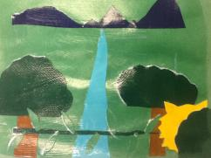
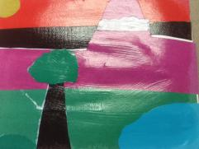
Visual Arts Lesson

Collage Landscape
Authors: Michael Washington with Carol Gould
Grade Level: Multiple (2nd through 5th)

Enduring Understanding
Landscape compositions can have foreground, background, and middle ground to show depth in space. Torn or cut paper can be arranged and layered to create depth in a landscape collage.
Lesson Description (Use for family communication and displaying student art)
Students view different types of landscapes (desert, forest, mountain, pastoral) to gain an understanding of depth through use of a foreground, background, and middle ground (FBM). Students identify FBM in works of art, as well as identify that objects in the foreground appear larger, whereas objects in the background appear smaller. Students learn collage technique as the medium of choice for a landscape representation. These steps include cutting or tearing paper, layering from the top down to guide the illusion of depth, as well as arranging the entire piece before gluing it, as to allow editing of their work.
Learning Targets and Assessment Criteria
Target: Identifies depth of space in a landscape.
Criteria: Correctly labels background, foreground, and middle ground (FBM) on a black and white landscape handout photo.

Target: Creates depth through layering of paper.
Criteria: Creates a landscape composed top down of layered cut and torn paper that clearly shows background, foreground, and middle ground (FBM).

Target: Uses good craftsmanship to finalize arrangement.
Criteria: Glues carefully to secure all pieces without edges sticking out.
Vocabulary
Arts:
Arrange
Background
Collage
Craftsmanship
Cut
Depth
Foreground
Horizon Line
Landscape
Layer
Middle Ground
Overlap
Realistic
Setting
Space
Tear
Top Down

Learning Standards
WA Arts State Grade Level Expectations
For the full description of each WA State Arts Grade Level Expectation, see: http://www.k12.wa.us/Arts/Standards
1.1.2 Elements: Shape
1.1.5 Elements: Space
1.2.1 Skills and Techniques: Collage
2.1.1 Creative Process
2.3.1 Responding Process

Early Learning Guidelines, if applicable
For a full description of Washington State Early Learning and Child Development Guidelines see: http://www.k12.wa.us/EarlyLearning/guidelines.aspx
(3rd Grade) 5. Communicating: Use listening skills to interpret information. 6. Learning about my world: Work at an activity until it is complete.

Materials
Museum Artworks or Performance
TAM: Eugene Louis Boudin, Washerwomen of Trouville, 1896

Utagawa Hiroshige, In the Midst of the Izu Mountains, 1850 1971.131.15

SAM: Alexander Calder, The Eagle, 1971 2000.69

Sanford Robinson Gifford, Mount Rainer, Bay of Tacoma, 1875 90.29
Desert landscape photo

Materials
Photo copies of Washerwomen
Landscape photos, images of landscapes/nat. geo landscapes, calendar pages.
8.5 by 11 white paper, scissors, assorted colored fadeless paper, glue sticks, file folders,
Mod podge, glue brushes, cups

Pre-Teach
ICON KEY:

= Indicates note or reminder for teacher

= Embedded assessment points in the lesson

Notice words describing and pictures of landscapes in children’s literature.
Lesson Steps Outline
1. Introduce concept of landscape.

Criteria-based teacher room scan/process assessment: Participates by responding to art.

2. Guide students in labeling Washerwoman photocopy to show understanding of FBM.

Criteria-based teacher checklist: Correctly labels background, foreground, and middle ground (FBM) on a black and white landscape handout photo.

3. Demonstrate cutting, tearing, and overlapping to create depth in a landscape composition.

Criteria-based process assessment: Student eyes on teacher will show that they are processing the steps of making a landscape collage. See if students are answering questions appropriately and on topic.

4. Guide students as they visualize and construct landscape collages using top down layering and craftsmanship.

Criteria-based teacher checklist: Creates a landscape composed top down of layered cut and torn paper that clearly shows background, foreground, and middle ground (FBM). Glues carefully to secure all pieces without edges sticking out.

5. Guide whole class reflection on student art.

Criteria-based group reflection: Describes illusion of depth and artistic choices in own and peer art work.

LESSON STEPS____________________________________________
1. Introduce concept of landscape.

- Today we are going to look at some photos and works of art that are called landscapes. Landscapes do two things, they represent something that we would see in the real world, and they show depth in space by using a background, foreground, and middle ground. An artist uses depth to make their work of art look realistic.

Teacher will demonstrate identifying background, middle ground, and foreground in one of the photos.

- In this photo (sculpture park photo) you can see that the clouds are in the background, the sculpture is in the middle ground, and that the trees are in the foreground. I also want to point out that where the water meets the sky is called the horizon line. The horizon line is a good way to figure out where the middle ground meets the background. Also pay attention to the trees in this photo, see how they look real large. Things in the foreground are larger, they are closer to you, and the boat in the background is smaller because it is farther away.

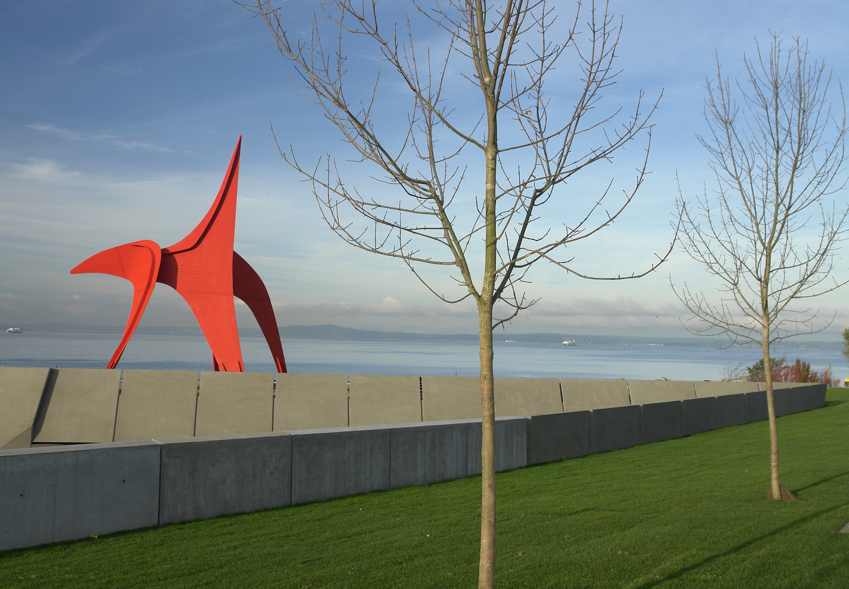
- Now it is your chance to identify depth in landscape photos and artwork.

Teacher guides the students in coming up to the screen and pointing with their hands where the background, foreground, and middle grounds are. Teacher will do this first with one of the photos, and then two pieces of art (desert landscape photo, Hiroshige, and Gifford).

- Please make sure to say what area of the landscape you are pointing to.

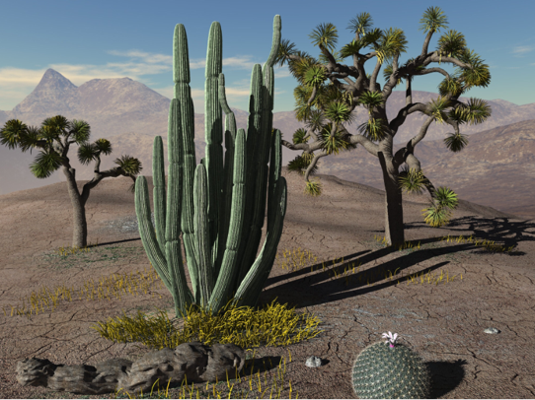

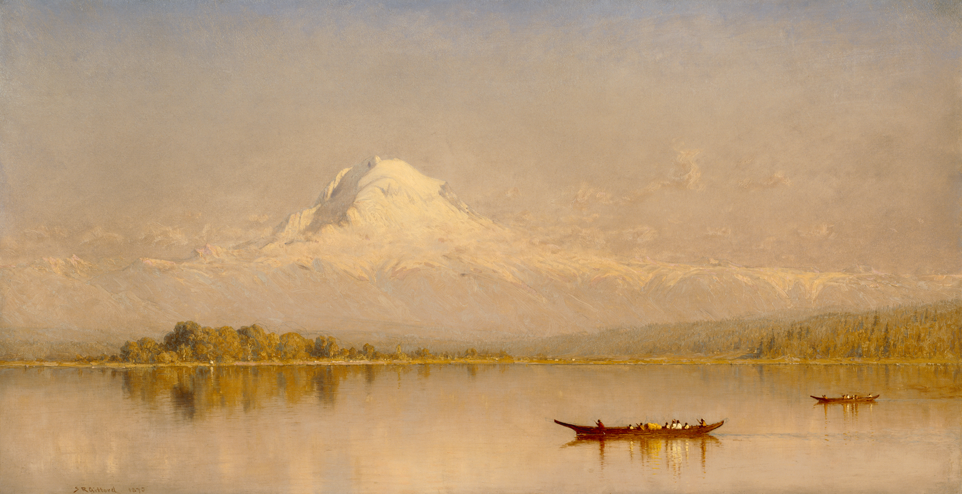

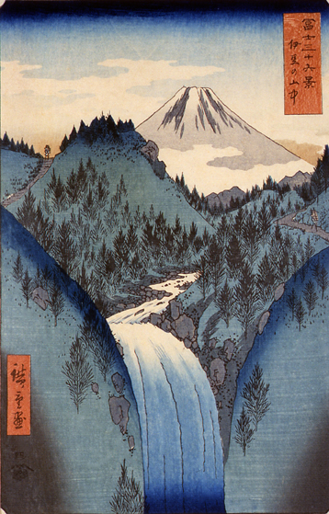

Criteria-based teacher room scan/process assessment: Participates by responding to art.
_______________________________________________________________________

2. Guide students in labeling Washerwoman photocopy to show understanding of FBM.

- Now it is your chance to show me what you have learned about landscapes. I want you to label on this copy of an art piece called Washerwomen at Trouville, where the FBM is.

After the students have completed their quick check and the papers have been collected, teacher will go through Washerwomen pointing out the features of the work that will help reinforce the earlier targets introduced in the beginning of the lesson.

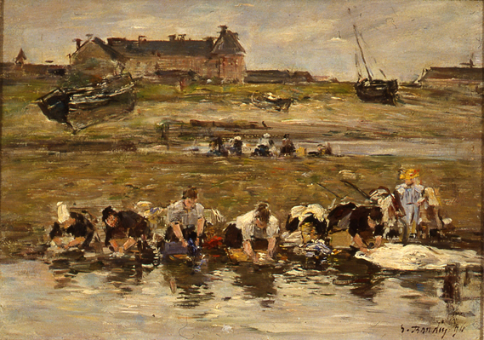

Criteria-based teacher checklist: Correctly labels background, foreground, and middle ground (FBM) on a black and white landscape handout photo.
_______________________________________________________________________

3. Demonstrate cutting, tearing, and overlapping to create depth in a landscape composition.

- What is a collage?

Take two responses, and then share definition.

- A collage is a piece of art that uses multiple pieces of cut and/or torn paper, that is layered, overlapped, arranged, and finally glued to make a work of art. Today you are going to use the collage technique to create a landscape that shows depth.

Option: Students can use whole sheet for background to eliminate the white space.

- I am going to show you what this all looks like. First I need to decide what the setting of my landscape will be (desert). I am going to pick a color for my sky/background, notice that I am starting at the top and that I am using a piece of paper that covers the width of the page, almost like painting it with paper.

- Then I get to decide where my background ends and meets my middle ground. I am going to pick a piece of color for my ground and cover the entire bottom half. Then I get to layer all the different things that you find in a desert in the middle ground and foreground. When I am done there will be no white left on my page. I want the middle ground to have some things in it.

- We know that a desert has cactus and rocks, so I will put a few of these where the sky meets the ground. I am going to make them big but not too big because as we remember the objects in the foreground are the largest because they are closest to you. I am going to put another cactus in the foreground but make it much larger than the one in the middle to show depth.

- Notice how I have not glued anything at all. Why do you think I am doing this? That is right! If you start to glue and want to make changes, you are stuck, literally! So follow this rule of thumb, cut and tear, arrange, when it looks perfect to you, and then it is time to glue.

Criteria-based process assessment: Student eyes on teacher will show that they are processing the steps of making a landscape collage. See if students are answering questions appropriately and on topic.
_______________________________________________________________________

4. Guide students as they visualize and construct landscape collages using top down layering and craftsmanship.
Provide diverse landscape photos to inspire students.

- Now I know that it sometimes hard to imagine a landscape up in your head out of nowhere. I have provided for you lots of different landscapes to look at that come from lots of different places.

- Look through them with your table buddy for a few minutes to get inspired on what type of landscape you want to create. Remember that you are not copying, the colors do not have to match perfectly, and they can be super bright if you want them to be. That is the fun of collage.

Students look through examples for a few minutes. They will raise their hand when they have an idea, student will verbalize their choice to teacher to make sure they are on the right path, then students will collect one 8.5 by 11 inch white paper, and three pieces of fadeless color paper, and scissors if desired.

- I want you to take only three pieces of colored paper first that way we use only what we need and you are always welcome to get more when you need it, just raise your hand.

As students begin to arrange their landscapes teacher will circulate and provide assistance where needed, using examples of student work to reinforce the guidelines of the lesson.

- Remember to cover the whole page, start from the top, pick where your horizon line is going to be so you know where your background is, don’t make the shapes too small or you will be cutting for days, glue last when it feels just right to you.

When the first few students are ready to glue, teacher will stop the whole class and demonstrate carful craftsmanship in using the glue sticks.

- Notice that I am not gluing the whole page first, I only glue what I want to stick and then press it down. I don’t press too hard, that way no clumps get on my pieces of colored paper,

- I make sure to get glue all the way to the edge so nothing sticks out or up, and that I glue the items that are on the bottom of my layers first then build my way up.

Mod Podge can be brushed across collages by teacher, if desired.

Criteria-based teacher checklist: Creates a landscape composed top down of layered cut and torn paper that clearly shows background, foreground, and middle ground (FBM). Glues carefully to secure all pieces without edges sticking out.
_______________________________________________________________________

5. Guide whole class reflection on student art.
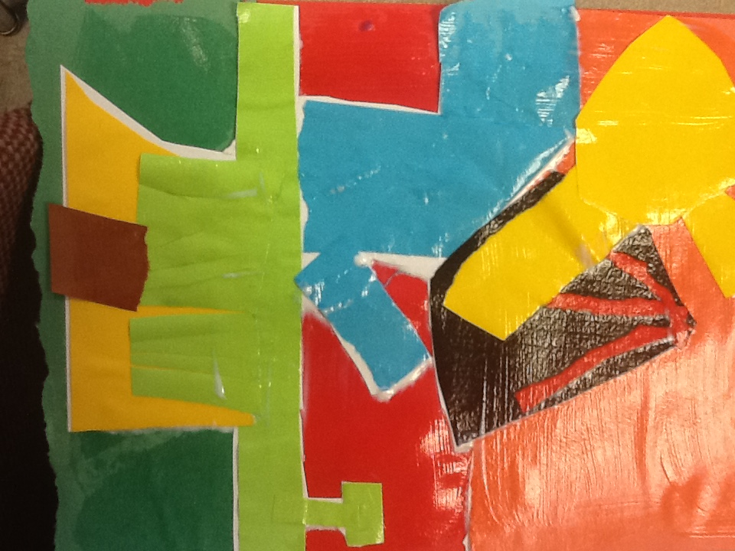
Display student art.

- Notice and talk about landscapes that capture your eye.

- What looks the closest? What looks the farthest away?

- Did you create the illusion of depth in your landscape?
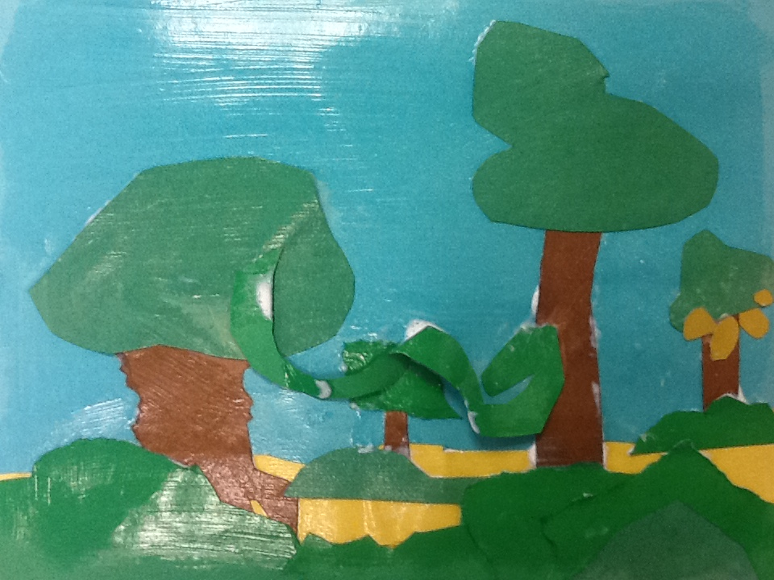

Criteria-based group reflection: Describes illusion of depth and artistic choices in own and peer art work.
_______________________________________________________________________
ARTS IMPACT LESSON PLAN Arts Foundations Visual Arts Lesson
2nd-5th: Landscape Collage
CLASS ASSESSMENT WORKSHEET

Disciplines | VISUAL ARTS |  |  | Total  3
Concept | Space | Collage: Depth | Craftsmanship
Criteria  Student Name | Correctly labels foreground, background, and middle ground (FBM) on a black and white landscape handout photo. | Creates a landscape composed top down of layered cut and torn paper that clearly shows FBM. | Glues carefully to secure all pieces without edges sticking out.
1.
2.
3.
4.
5.
6.
7.
8.
9.
10.
11.
12.
13.
14.
15.
16.
17.
18.
19.
20.
21.
22.
23.
24.
25.
26.
27.
28.
29.
30.
Total
Percentage

What was effective in the lesson? Why?

What do I want to consider for the next time I teach this lesson?

How could I connect the concepts in this lesson with other disciplines?

Teacher: Date:
ARTS IMPACT FAMILY LETTER

ARTS LESSON: Landscape Collage

Dear Family:

Today your child participated in a Visual Arts lesson. We talked about different types of landscapes (desert, forest, mountain, pastoral) to gain an understanding of depth through use of a foreground, background, and middle ground (FBM).

- We discovered foreground, background and middle ground (FBM) in works of art.

- We learned collage techniques as the medium of choice for a landscape representation.

- We created our collage by cutting or tearing paper and layering from the top down to guide the illusion of depth.

- We arranged our entire collage before gluing it, as to allow for editing of our work.

At home, you could collect interesting scrap papers (junk mail, cards, gift wrapping, catalogs, magazines) and create collages of cityscapes showing FBM.

Enduring Understanding

Landscape compositions can have foreground, background, and middle ground to show depth in space. Torn or cut paper can be arranged and layered to create depth in a landscape collage.

