**ARTS IMPACT LESSON PLAN**

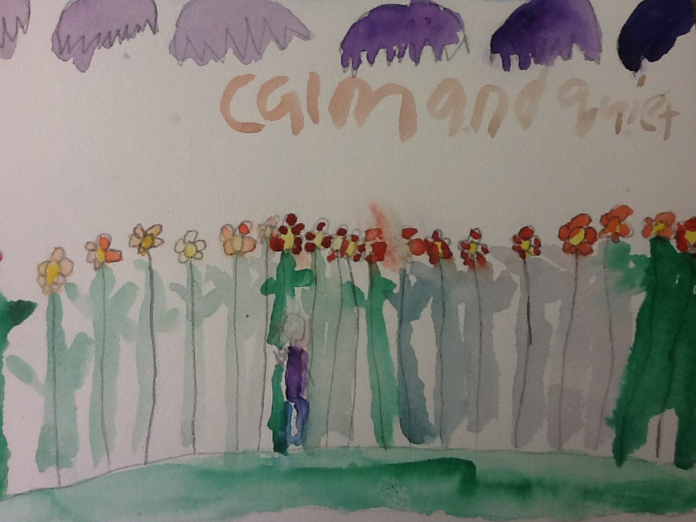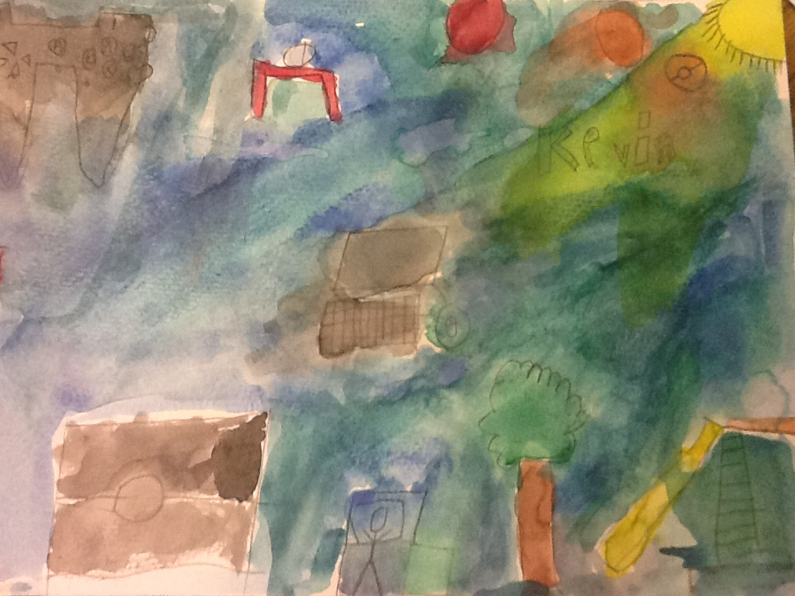**Visual Arts Lesson**

***Happy Place Watercolor Composition***

Authors: Helen Suh with Carol Gould

Grade Level: 2

**Enduring Understanding**

Artists use line and color to convey feelings through their works of art.

**Lesson Description (Use for family communication and displaying student art)**

*Students use creative thinking skills to create an expressive watercolor composition of a place(s) or thing(s). Students use line and color to convey feelings such as happy, calm, safe, joyful, peaceful, or loving in their artwork.*

**Learning Targets and Assessment Criteria**

**Target:** Understands that feelings can be shown through images.

**Criteria:** Discusses how they think an artist felt when creating various works of art.

**Target:** Identifies and expresses specific feelings in art.

**Criteria:** Writes feeling words on sticky notes that reflect what various works of art express.

Sketches images that convey happy, peaceful thoughts from memory/imagination.

**Target:** Thinks creatively.

**Criteria:** Gathers ideas, considers and tries multiple solutions, and makes artistic choices.

**Target:** Uses open composition and fills with color.

**Criteria:** Extends some shapes (shown as cut-off) beyond the edge of the picture,

adds watercolor to whole image.

.

**Vocabulary**

Arts:

Artistic choices

Color - warm and cool

Creativity

Emotion

Express

Lines - chaos, calm

Open composition

Quick sketch

**Learning Standards**

**WA Arts State Grade Level Expectations**

*For the full description of each WA State Arts Grade Level Expectation, see:* [*http://www.k12.wa.us/Arts/Standards*](http://www.k12.wa.us/Arts/Standards)

1.1.1 Elements: Line

1.1.6 Elements: Color

1.2.1 Skills and Techniques: Watercolor Painting

2.1.1 Creative Process

2.3.1 Responding Process

**Early Learning Guidelines, if applicable**

*For a full description of Washington State Early Learning and Child Development Guidelines see:* [*http://www.k12.wa.us/EarlyLearning/guidelines.aspx*](http://www.k12.wa.us/EarlyLearning/guidelines.aspx)

(2nd Grade) 5. Communicating: Take part in conversations by linking his or her comments to the remarks of others, and asking and answering questions to gather additional information or deepen understanding of a topic.

**Materials**

**Museum Artworks or Performance**

Printed images of the following:

Morris Graves – *Summer Flowers for Denise* (SAM 78.7)

Jacob Lawrence – *American Lawyers* *and Clients* (SAM 94.74)

Ambrose Patterson – *Monterey Cypress Trees* (TAM)

Jacob Lawrence – *Brooklyn Stoop* (TAM)

Joe Max Emminger - *Our Music* (TAM)

2004.34.2 A-B

**Materials**

Sticky notes

Paper, pencil, erasers, watercolors, 9x12 watercolor paper, sketch paper (newsprint), water containers, brushes

**Pre-Teach**

**ICON KEY:**

🗏 = Indicates note or reminder for teacher

🗹 = Embedded assessment points in the lesson

Students practice using watercolor tools and materials.

**Lesson Steps Outline**

**Day One**

**1.** Help students understand that feelings can be shown through images.

🗹 Criteria-based teacher checklist: Discusses how they think an artist felt when creating various works of art. Writes feeling words on sticky notes that reflect what various works of art express.

**2.** Demonstrate sketching “what makes me happy”.

**3.** Support students as they sketch images that convey happy, peaceful thoughts from their own memory/imagination.

🗹 Criteria-based teacher checklist: Sketches images that convey happy, peaceful thoughts from memory/imagination.

**4.** Demonstrate and guide students in creating final drawing on watercolor paper using open composition.

🗹 Criteria-based peer reflection and teacher checklist: Gathers ideas, considers and tries multiple solutions, and makes artistic choices. Extends some shapes shown as cut-off beyond the edge of the picture.

**Day Two**

**5.** Guide students in painting final composition.

🗹 Criteria-based teacher checklist: Extends some shapes (shown as cut-off) beyond the edge of the picture, adds watercolor to whole image.

**LESSON STEPS____________________________________________**

**Day One**

**1. Help students understand that feelings can be shown through images.**

* *When you look at paintings or a work of art, they might make us a feel a certain way. Some feelings might be happy, calm, peaceful, joyous, etc.*

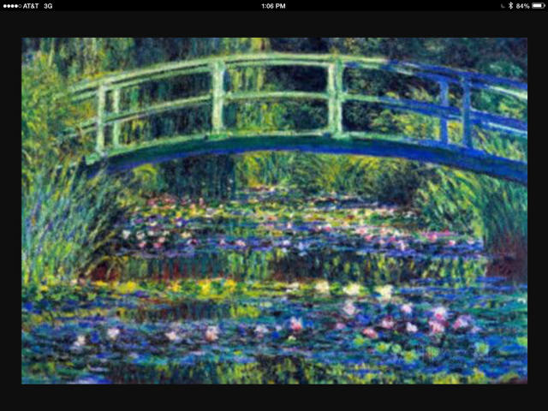

* *Now when you see look at this painting, what do you see? How does it make YOU feel? Artists use line and color to convey (show) feelings. Remember when we talked about CALM lines – curved lines are calm, repeated lines are calm. Soft colors (light colors) can give it a positive, happy feel. This painting was done by French painter by the name of Claude Monet. It was actually his home! And now his home is actually a museum and people can visit it and it actually still looks like THIS!*
* *And now let’s look at other works of art from SAM and discuss what feelings or thoughts you think the artist was sharing with us (students will do an ‘art gallery walk’ and write down words to identify their feelings/thoughts on a post-it which they’ll then stick around the various works of art).*

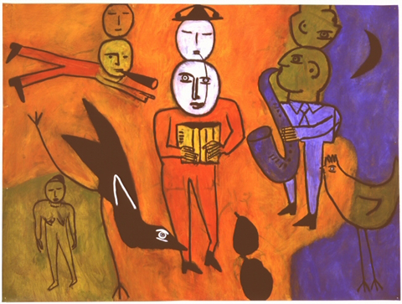

Joe Max Emminger,

*Our Music*

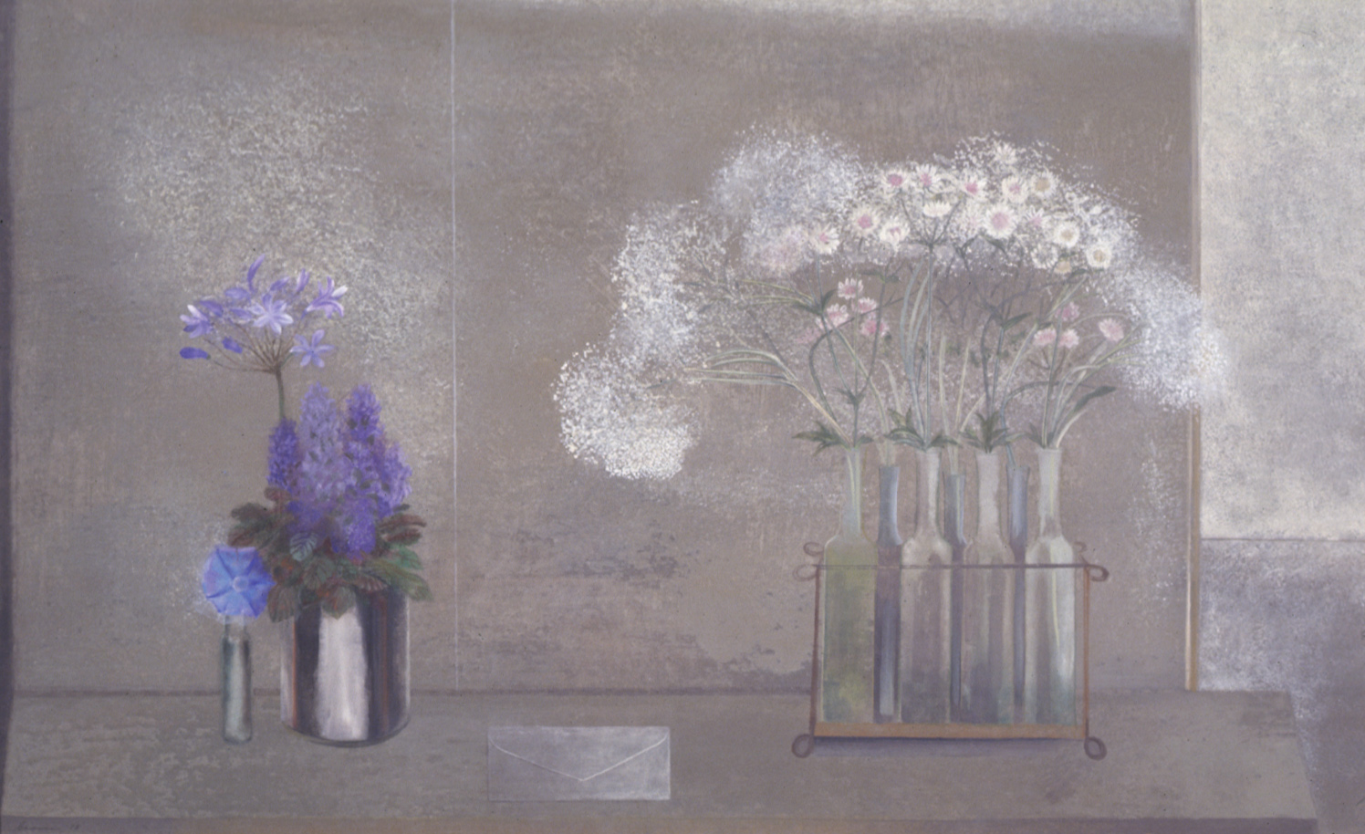

Morris Graves, *Summer Flowers for Denise*

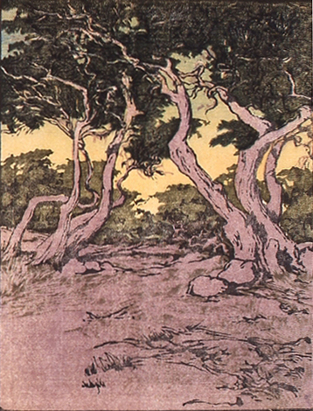

Ambrose Patterson, *Monterey Cypress Trees*

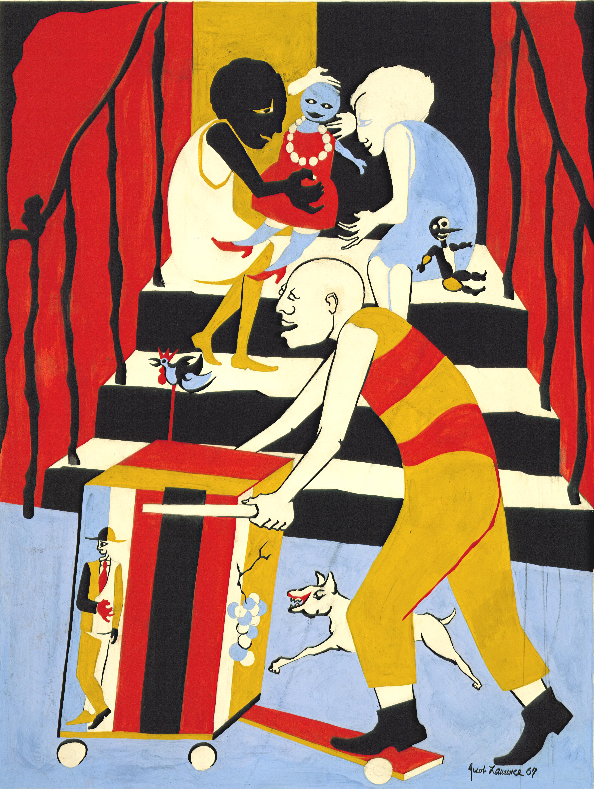

Jacob Lawrence,

*Brooklyn Stoop*

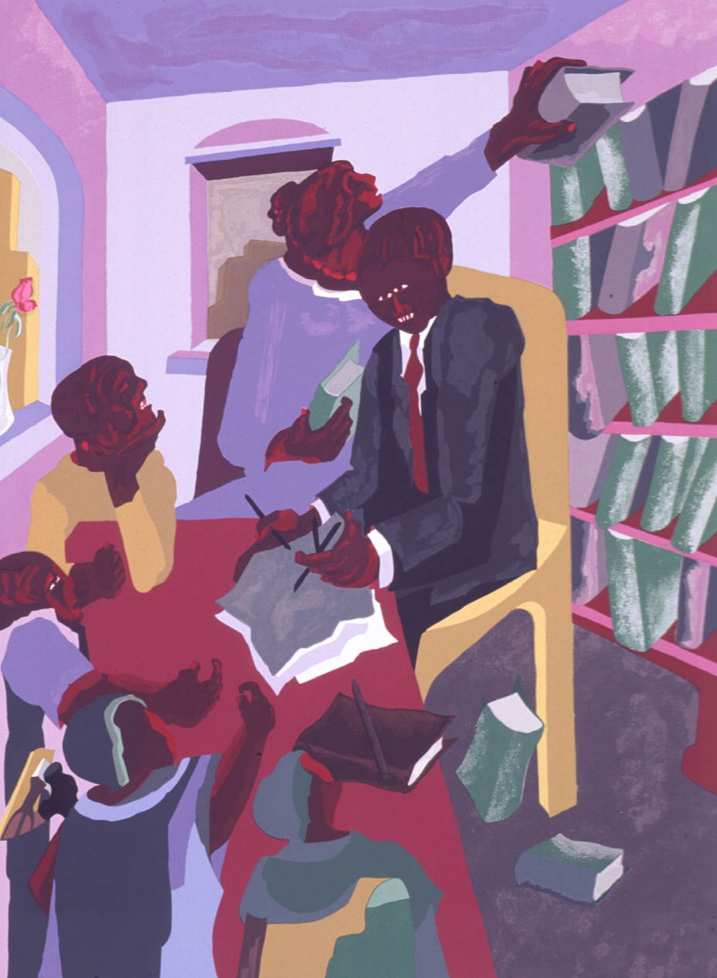

Jacob Lawrence,

*American Lawyers and Clients*

🗹 Criteria-based teacher checklist: Discuss how they think an artist felt when creating various works of art. Writes feeling words on sticky notes that reflect what various works of art express.

**_______________________________________________________________________**

**2. Demonstrate sketching “what makes me happy”.**

🗏 Students will reconvene on the rug and watch sketching demo.

* *We will be using newsprint to do our brainstorm sketches. When you get your newsprint paper, fold it horizontally and vertically so that you’ll end up with 4 spaces for sketching. We’re going to put on our creativity thinking caps on and think about something(s) that make You feel happy, peaceful, joyous, etc.*
* *Remember as artists, our ideas can change. I know my pictures don’t have to look realistic…I’m not going to make my drawings look too small and detailed since I’m going to use watercolors in the end.*

**_______________________________________________________________________**

**3. Support students as they sketch images that convey happy, peaceful thoughts from their own memory/imagination.**

* *Now it’s YOUR turn to sketch something(s) that make you feel happy, calm, peaceful, etc.*
* *This can be a place you’ve been to (or want to go to), something that makes you feel happy, calm, etc. or a combination of things. Try to think of a title for your final painting that will show (convey) the feelings of your piece!*

🗹 Criteria-based teacher checklist: Sketches images that convey happy, peaceful thoughts from memory/imagination.

**_______________________________________________________________________**

**4. Demonstrate and guide students in creating final drawing on watercolor paper using open composition.**

* *Let’s look at Jacob Lawrence’s Lawyers and Clients again and notice how he painted it with an OPEN COMPOSITION – when the artist extends things beyond the edge of the paper – using our imagination to ‘fill in’ what’s there (show painting - bookcase, table, person’s body, window, ceiling) – pretending it’s THERE but it’s not….*
* *Now let’s take one of your good ideas from your sketches and draw it on your watercolor paper. Make sure to use BIG images, not too detailed and open composition.*
* *Share with the person sitting next to you, what you’re going to draw and the feelings that you hope your finished painting will show.*

🗹 Criteria-based peer reflection and teacher checklist: Gathers ideas, considers and tries multiple solutions, and makes artistic choices. Extends some shapes shown as cut-off beyond the edge of the picture.

**_______________________________________________________________________**

**LESSON STEPS____________________________________________**

**Day Two**

**5. Guide students in painting final composition.**

* *Coach: Remember the #1 ingredient in watercolor is water. The colors should go with the feeling you hope to convey (show). Will you use warm colors? Will you use cool colors?*
* *Coach simple watercolor techniques: wash, drying, bleed (teacher will model wash, bleed and show example of teacher piece).*
* *Now, it’s YOUR turn to paint! After your paint is dry, write your title in the bottom middle of your paper with pencil.*

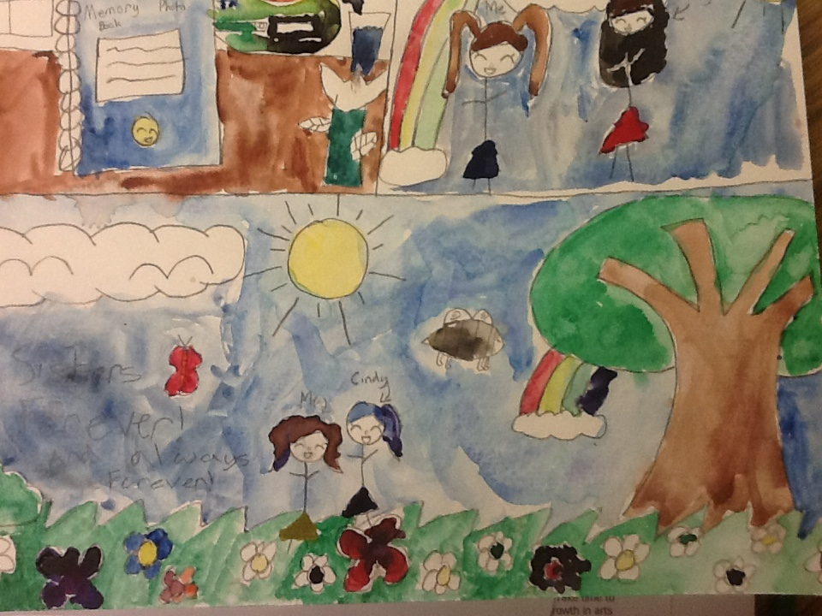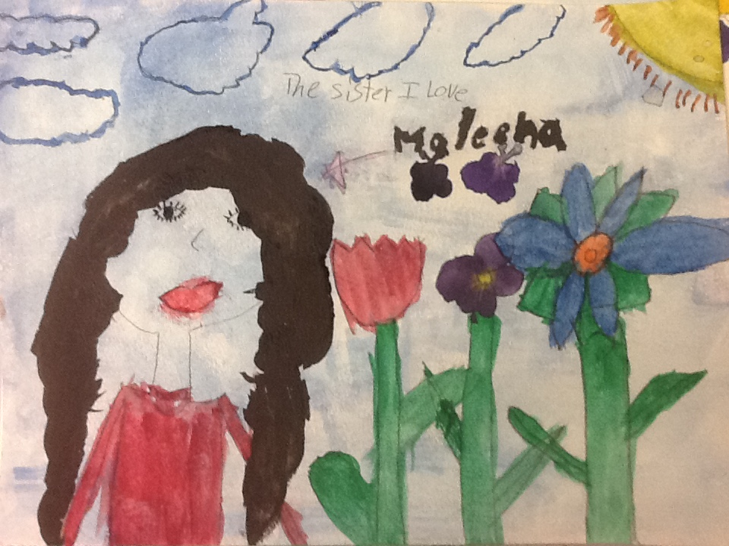

🗹 Criteria-based teacher checklist: Extends some shapes (shown as cut-off) beyond the edge of the picture, adds watercolor to whole image.

**_______________________________________________________________________**

**ARTS IMPACT LESSON PLAN Arts Foundations Lesson**

Grade 2: *Happy Place Watercolor Composition*

**CLASS ASSESSMENT WORKSHEET**

|  |  |  |  |  |  |  |
| --- | --- | --- | --- | --- | --- | --- |
| Disciplines | **VISUAL ARTS** | | | | | Total  5 |
| Concept | Expressive Qualities/Conveying Emotion | | | Creativity | **Open Composition** |
| Criteria  Student Name | Discuss how they think an artist felt when creating various works of art. | Writes feeling words on sticky notes that reflect what various works of art express. | Sketches images that convey happy, peaceful thoughts from memory/  imagination. | Gathers ideas, considers and tries multiple solutions, and makes artistic choices. | Extends some shapes (shown as cut-off) beyond the edge of the picture, adds watercolor to whole image. |
| 1. |  |  |  |  |  |  |
| 2. |  |  |  |  |  |  |
| 3. |  |  |  |  |  |  |
| 4. |  |  |  |  |  |  |
| 5. |  |  |  |  |  |  |
| 6. |  |  |  |  |  |  |
| 7. |  |  |  |  |  |  |
| 8. |  |  |  |  |  |  |
| 9. |  |  |  |  |  |  |
| 10. |  |  |  |  |  |  |
| 11. |  |  |  |  |  |  |
| 12. |  |  |  |  |  |  |
| 13. |  |  |  |  |  |  |
| 14. |  |  |  |  |  |  |
| 15. |  |  |  |  |  |  |
| 16. |  |  |  |  |  |  |
| 17. |  |  |  |  |  |  |
| 18. |  |  |  |  |  |  |
| 19. |  |  |  |  |  |  |
| 20. |  |  |  |  |  |  |
| 21. |  |  |  |  |  |  |
| 22. |  |  |  |  |  |  |
| 23. |  |  |  |  |  |  |
| 24. |  |  |  |  |  |  |
| 25. |  |  |  |  |  |  |
| 26. |  |  |  |  |  |  |
| 27. |  |  |  |  |  |  |
| 28. |  |  |  |  |  |  |
| 29. |  |  |  |  |  |  |
| 30. |  |  |  |  |  |  |
| Total |  |  |  |  |  |  |
| Percentage |  |  |  |  |  |  |

*What was effective in the lesson? Why?*

*What do I want to consider for the next time I teach this lesson?*

*How could I connect the concepts in this lesson with other disciplines?*

Teacher: Date:

**ARTS IMPACT FAMILY LETTER**

ARTS LESSON: ***Happy Place Watercolor Composition***

Dear Family:

Today your child participated in a **Visual Arts** lesson. We talked about how artwork

can convey feelings.

* We identified specific emotions expressed in art from Tacoma and Seattle Art Museum.
* We used use creative thinking skills to create an expressive watercolor composition of a place

or thing.

* We used line and color to convey feelings such as happy, calm, safe, joyful, peaceful, or loving in our artwork.

At home, you could create colorful pictures that express feelings about home, friends and family.

**Enduring Understanding**

Artists use line and color to convey feelings through their works of art.