**ARTS IMPACT LESSON PLAN**

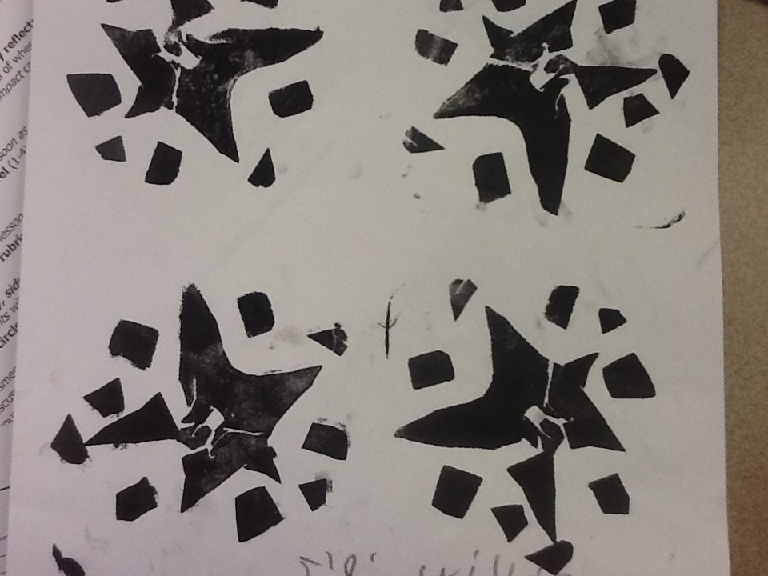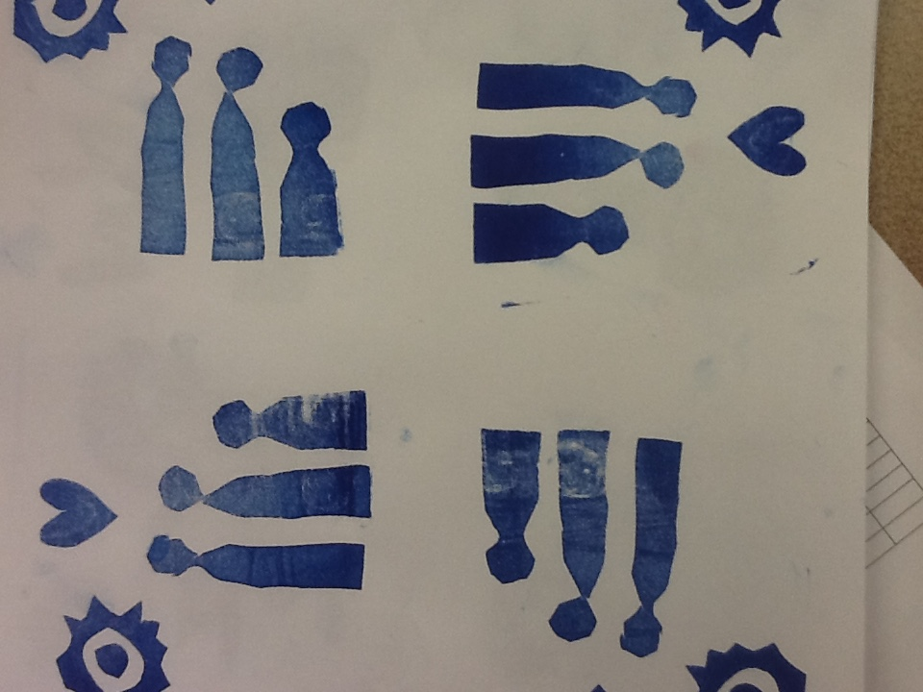**Visual Arts Lesson**

***Personal Symbol Tile Prints***

Authors: Elizabeth Enriquez with Carol Gould Grade Level: 1

**Enduring Understanding**

Symbols can have a personal meaning. An image can be printed, rotated and repeated to create a new, different design.

**Lesson Description (Use for family communication and displaying student art)**

*Students design a personal symbol and create a stamp using fun foam. Students learn print making techniques and use their stamp in a repeated rotational manner to print a four print tile design.*

**Learning Targets and Assessment Criteria**

**Target:** Designs a personal symbol.

**Criteria:** Draws a unique shape that relates to self.

**Target:** Creates a stamp block.

**Criteria:** Transfers design, cuts foam shapes with precise edges, and applies foam to block.

**Target:** Prints pattern, repeats image to form a new design.

**Criteria:** Prints design using ¼ (90 °) rotations to form a four print tile design.

**Vocabulary**

Arts:

Design

Ink

Ink pad

Pattern

Print making

Repetition

Rotation

Shape

Symbol

Tile

**Materials**

**Museum Artworks or Performance**

**SAM:**

Persian, 15th century

Tile with twelve-pointed star 39.61

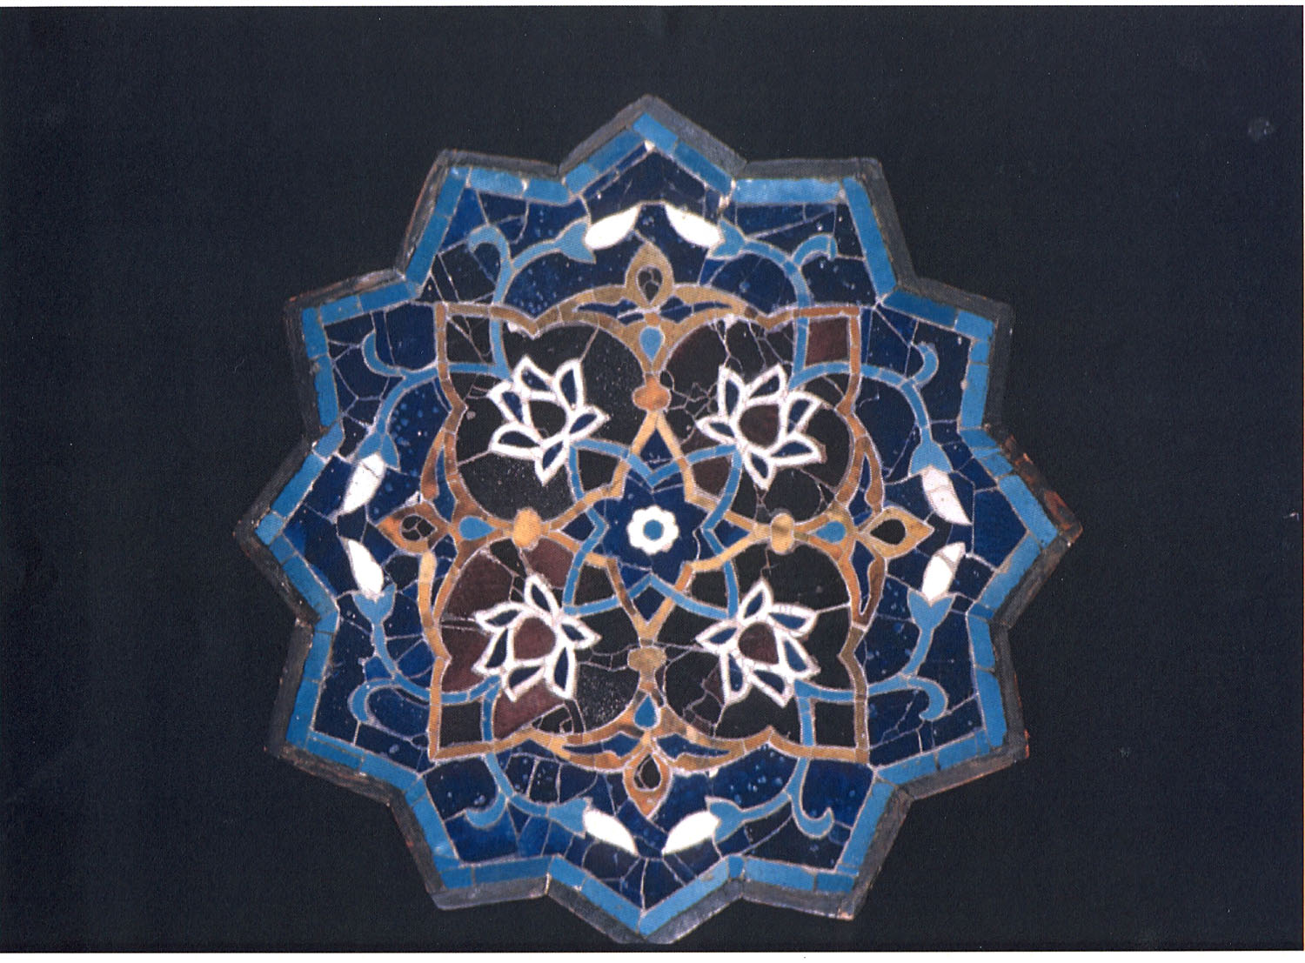

**Materials**

Scratch paper for design

Fun foam

Wood blocks

Ink Stamp Pads

Palette knife

Paper for final print

Scissors

**Learning Standards**

**WA Arts State Grade Level Expectations**

*For the full description of each WA State Arts Grade Level Expectation, see:* [*http://www.k12.wa.us/Arts/Standards*](http://www.k12.wa.us/Arts/Standards)

1.1.2 Elements: Shape

1.2.1 Skills and Techniques: Printmaking

1.1.7 Principles of Design: Repetition

2.1.1 Creative Process

2.2.1 Presenting Process

2.1.3 Responding Process

4.2.1 Connection between Visual Arts and Math

**Common Core State Standards (CCSS) in Math**

[*http://www.k12.wa.us/CoreStandards/Mathematics/default.aspx*](http://www.k12.wa.us/CoreStandards/Mathematics/default.aspx)

1.G.2. Compose two-dimensional shapes (rectangles, squares, trapezoids, triangles, half-circles, and quarter-circles) or three-dimensional shapes (cubes, right rectangular prisms, right circular cones, and right circular cylinders) to create a composite shape, and compose new shapes from the composite shape.

**Early Learning Guidelines, if applicable**

*For a full description of Washington State Early Learning and Child Development Guidelines see:* [*http://www.k12.wa.us/EarlyLearning/guidelines.aspx*](http://www.k12.wa.us/EarlyLearning/guidelines.aspx)

1st Grade: 5.Communicating: Develop listening and observation skills. 6. Learning About my world: Math: Make composite shapes by joining shapes together. Arts: Create and respond to arts.

**Pre-Teach**

**ICON KEY:**

🗏= Indicates note or reminder for teacher

🗹= Embedded assessment points in the lesson

Lead student discussion about symbols and how they are used to represent ideas, things and people.

**Lesson Steps Outline**

**Day One**

**1.** Discuss and identify common symbols. A symbol is an agreed upon visual image that has specific meaning.

🗹 Criteria-based peer process assessment: Shares ideas for symbols.

**2.** Guide students in creating personal symbol designs.

🗹 Criteria-based teacher checklist: Draws a unique shape that relates to self.

**3.** Guide students as they transfer their design to the foam and stick it to the block.

🗹 Criteria-based teacher checklist: Transfers design, cuts foam shapes with precise edges, and applies foam to block.

**Day Two**

**4.** Facilitate students viewing the Persian tile with twelve pointed star and noticing how the images have rotated 90 degrees.

🗹 Criteria-based teacher check for understanding: Responds to demonstration and art.

**5.** Guide students printing using their personal symbol block, rotating block to create the four print tile design.

🗹 Criteria-based teacher checklist: Prints design using ¼ (90 °) rotations to form a four print tile design.

**6.** Students display prints for gallery walk. Guide student reflection.

🗹 Criteria-based class reflection: Talks about symbols, shapes, and printmaking.

**LESSON STEPS____________________________________________**

**Day One**

**1. Discuss and identify common symbols.**

🗏Teacher shows girl/boy bathroom signs, recycle, plus or minus signs, and McDonald’s arches*.*

* *Do you recognize these, what are they? What do they represent? How do you know?*

**A symbol is an agreed upon visual image that has specific meaning.**

* *Today you are going to design your own symbol. We are going to think about what is important to us and make a list. Think of at least three things or words that can be used to describe you.*
* *Mine could be giving, bright and family. Turn and talk with your partner to share ideas.*

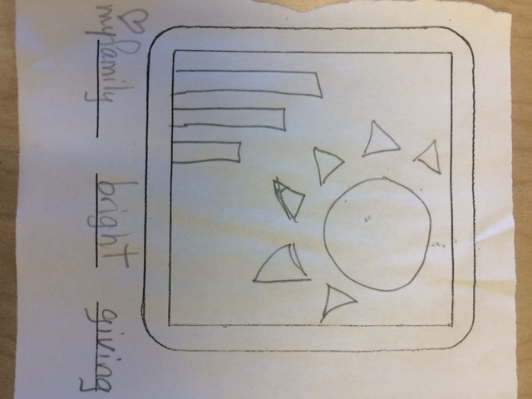

🗏 Teacher writes list of some personal attributes as students raise hand and call them out.

* *Let’s look at happy. What symbols could be used to represent happy? (draw happy face). What else can we use?*

🗏 Teacher coaches that parts of an image can be used to create a personal symbol*.*

🗹 Criteria-based peer process assessment: Shares ideas for symbols.

**_______________________________________________________________________**

**2. Guide students in creating personal symbol designs.**

* *At your desk you are going to make your own simple design. It is your turn to come up with two design ideas using the words you thought of when sharing with your partner.*

🗏 Students try to complete two designs using the graphic organizer. Teacher will create and copy.

* *Design should be simple and big because we are going to be cutting it out of foam and sticking it onto a block for printing.*

🗏 Students at this point can choose to edit their stamp design.

🗹 Criteria-based teacher checklist: Draws a unique shape that relates to self.

**_______________________________________________________________________**

**3. Guide students as they transfer their design to the foam and stick it to the block.**

* *Pick your favorite design and we are going to make it a printable image. Watch as I trace my design onto the foam using my folded graphic organizer. I can cut through my design if I need to because the foam will stick together once it is on the block (i.e. center of donut). Once I trace to the foam I need to cut my design and stick it to my printing block.*

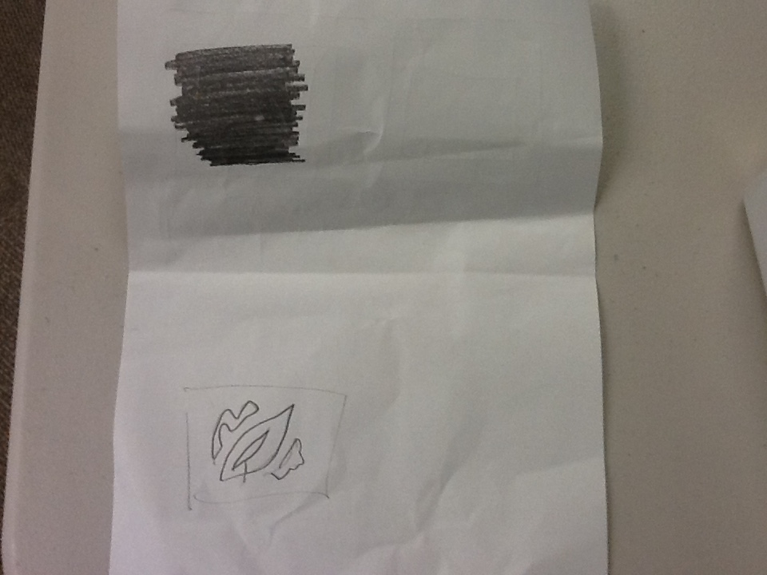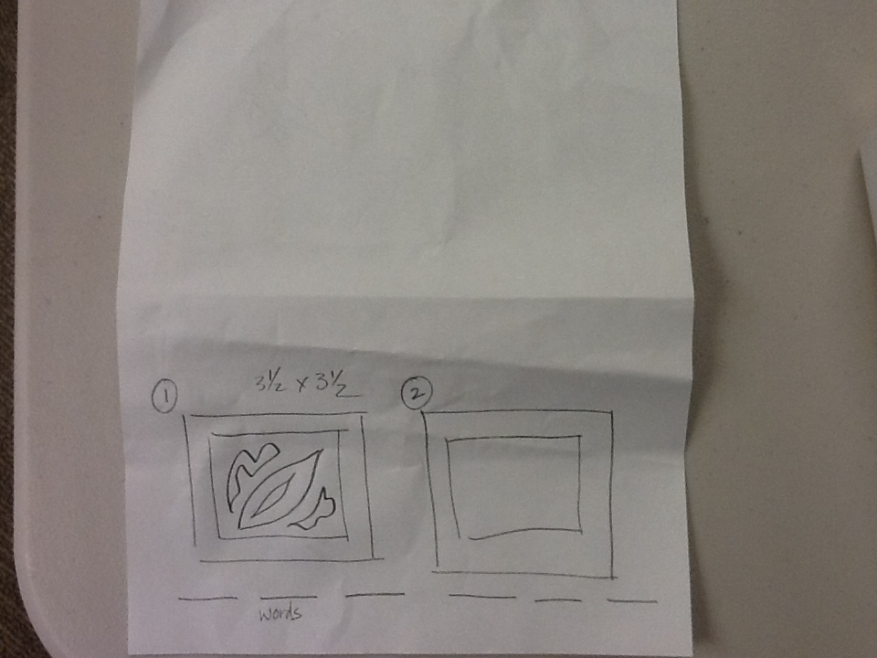

🗹 Criteria-based teacher checklist: Transfers design, cuts foam shapes with precise edges, and applies foam to block.

**_______________________________________________________________________**

**Day Two**

**4. Facilitate students viewing the Persian tile with twelve pointed star and noticing how the images have rotated 90 degrees.**

🗏 Models folding the image to show each quartered design.

* *I chose this image because of the clear design. This is ceramic tiles. What do you see? What do you notice?*

🗏Teacher folds image horizontally and vertically to show rotation of flower design.

* *We are going to print our symbols four times on a piece of paper carefully rotating it 90 degrees each time like the flower.*



🗹 Criteria-based teacher check for understanding: Responds to demonstration and art.

**_______________________________________________________________________**

**5. Guide students printing using their personal symbol block, rotating block to create the four print tile design.**

* *Take the block in your hands and look at your design. Stand the block so design is looking at you. Take a pencil and write a T at the top side edge. Put your pencils down. Let your block fall so design is on paper and you are looking at the T. Now we are going to take our stamp and pretend we are stamping on our paper without using the ink.*

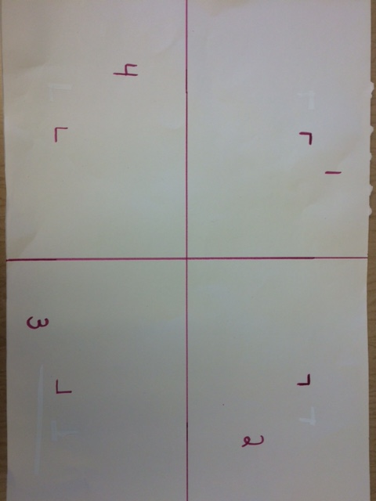

* *The first print will need to be placed so that the T is looking at number 3. Please do that. For the second print, turn your block one rotation so that the T matches number 4. Say “rotate” every time you turn the T to match the number. Now turn “rotate” your block to match number 1 and the final rotation turn the T to match number 2.*
* *Now it is time to use ink and print your design on paper. Start by placing your stamp on the inked stamp pad. This will put ink on your stamp. When ready, pick up your stamp and place it on your paper matching the T to a number. Put more ink in your stamp BEFORE making another print, otherwise your design might not print completely. You can start.*

🗏 Teacher demonstrates how to put ink on the stamp and use the ink pad to transfer the ink to the stamp and how to stamp on the final paper.

🗹 Criteria-based teacher checklist: Prints design using ¼ (90 °) rotations to form a four print tile design.

**_______________________________________________________________________**

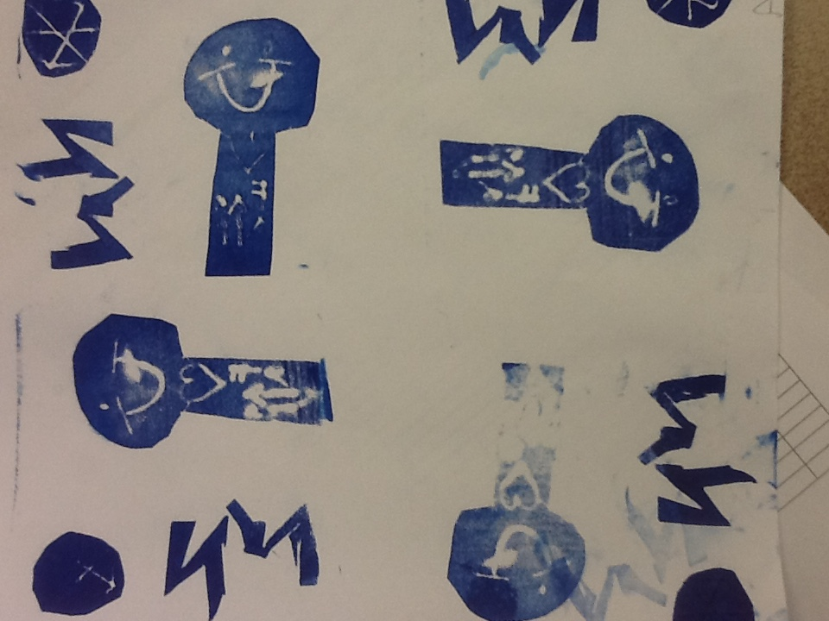**6. Students display prints for gallery walk. Guide student reflection.**

* *Tell an elbow buddy about your personal symbol.*
* *Point to place where you combined shapes to make a new, larger shape.*
* *Share a challenge and solution in making your stamp and printing your tile design.*

🗹 Criteria-based class reflection: Talks about symbols, shapes, and printmaking.

**_______________________________________________________________________**

**ARTS IMPACT LESSON PLAN Arts Foundations Visual Arts Lesson**

Grade 1: *Personal Symbol Tile Prints*

**CLASS ASSESSMENT WORKSHEET**

|  |  |  |  |  |
| --- | --- | --- | --- | --- |
| Disciplines | **VISUAL ARTS** | | | Total  3 |
| Concept | Symbol | Stamp | **Print** |
| Criteria  Student Name | Draws a unique shape that relates to self. | Transfers design, cuts foam shapes with precise edges, and applies foam to block. | Prints design using ¼ (90 °) rotations to form a four print tile design. |
| 1. |  |  |  |  |
| 2. |  |  |  |  |
| 3. |  |  |  |  |
| 4. |  |  |  |  |
| 5. |  |  |  |  |
| 6. |  |  |  |  |
| 7. |  |  |  |  |
| 8. |  |  |  |  |
| 9. |  |  |  |  |
| 10. |  |  |  |  |
| 11. |  |  |  |  |
| 12. |  |  |  |  |
| 13. |  |  |  |  |
| 14. |  |  |  |  |
| 15. |  |  |  |  |
| 16. |  |  |  |  |
| 17. |  |  |  |  |
| 18. |  |  |  |  |
| 19. |  |  |  |  |
| 20. |  |  |  |  |
| 21. |  |  |  |  |
| 22. |  |  |  |  |
| 23. |  |  |  |  |
| 24. |  |  |  |  |
| 25. |  |  |  |  |
| 26. |  |  |  |  |
| 27. |  |  |  |  |
| 28. |  |  |  |  |
| 29. |  |  |  |  |
| 30. |  |  |  |  |
| Total |  |  |  |  |
| Percentage |  |  |  |  |

*What was effective in the lesson? Why?*

*What do I want to consider for the next time I teach this lesson?*

*How could I connect the concepts in this lesson with other disciplines?*

Teacher: Date:

**ARTS IMPACT FAMILY LETTER**

ARTS LESSON: ***Personal Symbol Tile Prints***

Dear Family:

Today your child participated in a **Visual Arts** lesson. We talked about personal symbols, shapes, and rotating designs.

* We designed a personal symbol.
* We created a stamp using fun foam.
* We learned printmaking techniques.
* We printed our stamp in a repeated, rotational manner to make a four print tile design.

At home, you could develop a family symbol.

**Enduring Understanding**

Symbols can have a personal meaning.

An image can be printed, rotated and repeated to create a new, different design.