ARTS IMPACT LESSON PLAN
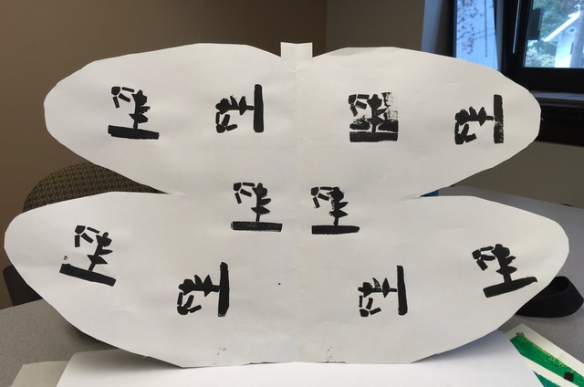
Visual Arts and Math Lesson

Symmetry: Butterflies and Printmaking
Authors: Laura Strand with Carol Gould Grade Level: K-2

Enduring Understanding
Identical shapes in reflection on both sides of an axis line create symmetry. When using a stamp, the inked surface is what creates positive space and can be repeated to create a pattern.

Lesson Description (Use for family communication and displaying student art)
This lesson begins with a focus on symmetry. Students use the fold in large paper as a simple line of axis to help them cut out a balanced butterfly-like shape. Students then create a unique original print stamp which is used to stamp patterns in a symmetrical fashion, onto their butterfly shape. Students use perseverance skills to complete this multi-step process.

Learning Targets and Assessment Criteria
Target: Applies the 21st skills of creative thinking and perseverance.
Criteria: Creates original design and adapts and persists through multiple steps needed to create printed butterfly.

Target: Applies principles of mirror symmetry.
Criteria: Carefully draws and cuts paper on axis line to create a butterfly-like shape in reflection.

Target: Creates a stamp for printmaking, uses to print in a pattern.
Criteria: Cuts precise shapes, arranges and applies foam design to block; applies opaque layer of paint to block each time it is printed and repeats printed image in a symmetrical balanced pattern.

Materials
Museum Artworks or Performance
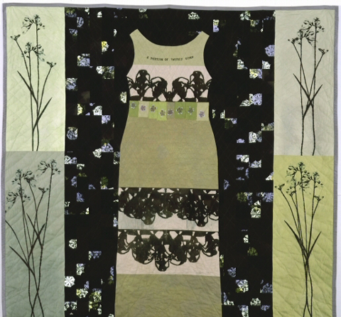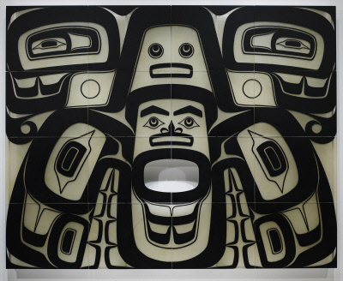

Tacoma Art Museum:
Rachel Brumer, Freesias for Madeline, 2003
Seattle Art Museum:
Preston Singletary, Keet Shagoon (Killer Whale), 2003

Materials
13” x 36” construction paper, pre-folded, pencils, scissors,
13” x 36” construction paper, pre- folded, pencils, scissors,
Fun Foam, 2 x 2 foam cubes, 8.5 x 5.5 inch sheet paper with graphic organizer of 2 X 2 squares for sketching out stamp ideas.
daubers (stencil sponges), acrylic paint,: black, paper plates (small) for paint, Newsprint: 9 X 12”

Vocabulary
Arts/Math Infused:
Axis
Pattern
Reflection
Shape
Symmetry

Arts:
Balance
Dauber/blotter
Design
Negative space
Paint
Positive space
Printmaking
Repetition
Stamp
Transfer

Learning Standards
WA Arts State Grade Level Expectations
For the full description of each WA State Arts Grade Level Expectation, see: http://www.k12.wa.us/Arts/Standards
1.1.2 Elements: Shape 1.1.5
1.1.5 Elements: Space – negative, positive
1.1.7 Principles of Organization: Balance, Symmetry, Repetition
1.2.1 Skills and Techniques: Printmaking
1.3.1 Styles of Cultures and Times: Symbols
2.1.1 Creative Process
2.3.1 Responding Process
4.2.1 Connection between Visual Arts and Math

Early Learning Guidelines (Pre-K – Grade 3)
For a full description of Washington State Early Learning and Child Development Guidelines see: http://www.del.wa.gov/development/guidelines/
(Age 4-5) 6. Learning about my world: Math: Match and sort simple shapes; create own patterns with a variety of materials. Arts: Show an increasing ability to use art materials safely and with purpose.

continued
National Core Arts Standards
1. Generate and conceptualize artistic ideas and work.
2. Organize and develop artistic ideas and work.
3. Refine and complete artistic work.
4. Select, analyze, and interpret artistic work for
presentation.
5. Develop and refine artistic techniques and work for presentation.
Arts: Show an increasing ability to use art materials safely and with purpose.

Common Core State Standards (CCSS) in Math
Related to the lesson
For a full description of CCSS Standards by grade level see:
http://www.k12.wa.us/CoreStandards/Mathematics/default.aspx
1.G.2. Compose two-dimensional shapes to create a composite shape.
4.OA.5. Generate a number or shape pattern that follows a given rule. Identify apparent features of the pattern that were not explicit in the rule itself.
4.G.3. Recognize a line of symmetry for a 2-dimensional figure as a line across the figure such that the figure can be folded along the line into matching parts.

CCSS Mathematical Practices
MP.5. Use appropriate tools strategically.
MP.6. Attend to precision.
MP.7. Look for and make use of structure.

Pre-Teach
ICON KEY:

= Indicates note or reminder for teacher

= Embedded assessment points in the lesson

Practice with placement of matching shapes and colors in symmetry.
Lesson Steps Outline
Day One
1. Introduce or review the shared concept of symmetry in math and visual art.
Have students hold their hands up together and then unfold them like butterfly wings.

Criteria-based process assessment: Creates symmetry with hands, thinks about perseverance.

2. Demonstrate and guide drawing and careful cutting of the butterfly-like shape along the central axis line. Students watch and then draw a unique shape that relates to half of a butterfly onto one side of folded paper and carefully cuts
it out.

Criteria-based teacher checklist and self-assessment: Carefully draws and cuts paper on axis line to create a butterfly-like shape.

3. Introduce and guide art analysis of Freesias for Madeline by Rachel Brumer from TAM and Keet Shagoon by Preston Singletary from SAM. Students participate in discussion of how the artist repeated shapes to create pattern and symmetry with an eye for the axis line (line of symmetry).

Criteria-based teacher and student process assessment: Participates in a turn-and-talk and group discussion in response to art.

Day Two
4. Review Keet Shagoon by Preston Singletary, taking time to notice individual shapes that were used in repetition to create a pattern. Review symmetry.

Criteria-based teacher process assessment: Participates in group review and discussion in response to art.

5. Demonstrate stamping with premade stamp to show how it works. Demonstrate creative thinking in combining precut shapes or developing a stamp design for an original stamp. Demonstrate cutting out and/or arranging and applying the shapes to the block so that the foam does not extend past the limits of the block. Guide students as they cut the shapes and/or arrange and attach to create a design on their block.

Criteria-based teacher checklist: Creates original design. Cuts precise shapes, arranges and applies foam design to block. Adapts and persists through multiple steps needed to create printed butterfly.

6. Demonstrate applying paint to stamp and then printing onto the newsprint to make a test print. Emphasize the amount of paint, pressure, and steadiness needed to fully transfer paint to butterfly-shaped paper in order to see the complete design.

Criteria-based group and peer reflection: Responds to questions by pointing and talking with a partner.

7. Guide students as they look at class set of butterflies (a group of butterflies is called a “kaleidoscope”).

Criteria-based process assessment and teacher checklist: Observes demonstration, assembles materials, and prepares workspace to stamp paper. Prints stamp in reflection: Applies opaque layer of paint to block each time it is printed and repeats printed image in a symmetrical balanced pattern. Adapts and persists through multiple steps needed to create printed butterfly.

LESSON STEPS____________________________________________
Day One
1. Introduce or review the shared concept of symmetry in math and visual art.
 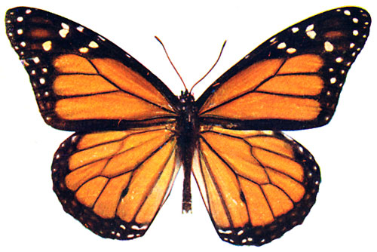
- Symmetry can be described as being equal on both sides of a centrally placed axis.

- Symmetry means the same thing in math and art.

- Symmetry means a mirror image—one side is the mirror image of the other.

- Symmetry can occur in any orientation as long as the image is the same and oriented in reflection on either side of the central axis.

Have students hold their hands up together and then unfold them like butterfly wings.

- Have you heard the word symmetry before? Do you know what it is?

- You can create symmetry with your hands. Look at your hands. Place your palms together, lining up your pinkies and your thumbs. Now open up your hands with your pinkies still touching, kind of like butterfly wings. The axis line is the line between your hands.

- We will be creating our own butterflies today in a multi-step process.

- When artists are working on art that has a lot of steps to it, they have to make sure that they stick with it and don’t give it, even when it is hard. This is called perseverance.

Criteria-based process assessment: Creates symmetry with hands, thinks about perseverance.
_______________________________________________________________________

2. Demonstrate and guide drawing and careful cutting of the butterfly-like shape along the central axis line. Students watch and then draw a unique shape that relates to half of a butterfly onto one side of folded paper and carefully cuts it out.
Hold paper like a book. Emphasize leaving the edge intact. Talk about difference between small, medium, large and gigantic shapes for wings that that fill the paper.

- Watch as I draw half of the butterfly shape. I have the fold on the left side (like a book) and I draw a giant “B” shape, making sure to touch the edges of my paper with the points of my butterfly wings.

- With paper still folded I will now carefully cut out my shape, being careful not to cut through my axis line.

- See how I have a symmetrical butterfly when my paper is unfolded.

- Now it is your turn.

Criteria-based teacher checklist and self-assessment: Carefully draws and cuts paper on axis line to create a butterfly-like shape.
_______________________________________________________________________

3. Introduce and guide art analysis of Freesias for Madeline by Rachel Brumer from TAM and Keet Shagoon by Preston Singletary from SAM. Students participate in discussion of how the artist repeated shapes to create pattern and symmetry with an eye for the axis line (line of symmetry).

- In Freesias for Madeline, do you think this counts as symmetry? (Introduce idea of balance)

- Sometimes in art we see a composition which is not exactly symmetrical, but is balanced.

- What is the same on each side of this work of art, and what is different?

- What parts of the design in Keet Shagoon (Killer Whale) are symmetrical?

Criteria-based teacher and student process assessment: Participates in a turn-and-talk and group discussion in response to art.
_______________________________________________________________________

Day Two
4. Review Keet Shagoon by Preston Singletary, taking time to notice individual shapes that were used in repetition to create a pattern. Review symmetry.

- What shapes do you see repeated? Where are they repeated?

- What patterns do you see horizontally and vertically?

Criteria-based teacher process assessment: Participates in group review and discussion in response to art.
_______________________________________________________________________

5. Demonstrate stamping with premade stamp to show how it works. Demonstrate creative thinking in combining precut shapes or developing a stamp design for an original stamp. Demonstrate cutting out and/or arranging and applying the shapes to the block so that the foam does not extend past the limits of the block. Guide students as they cut the shapes and/or arrange and attach to create a design on their block.

- Notice how I apply the paint and carefully stamp using an up and down motion.

- Today we are going to use sticky foam to create our own original stamp.

Younger students can combine precut shapes for an original stamp.
- I am going to creatively arrange sticky foam shapes in a design and stick onto my foam block or cube. This will be a stamp.

Older students can use a graphic organizer to sketch out ideas and then cut out own shapes
for stamps.

- When I am cutting out foam shapes, I am opening scissors fully, and turning both scissors and foam carefully in hand.

- This is the size of our cube that you will make a stamp out of, so all of the pieces need to fit onto it.

- The sticky foam shapes are the parts that are going to have paint on them. This will make positive space when we go to stamp it.

- The space in between the sticky foam will create the negative space: when stamped it will remain white.

- Watch how I hold up my cut shape to the foam block before peeling the backing off, to make sure it is going to fit how I want it to.

- Now it’s your turn.

Criteria-based teacher checklist: Creates original design. Cuts precise shapes, arranges and applies foam design to block. Adapts and persists through multiple steps needed to create printed butterfly.
_______________________________________________________________________

6. Demonstrate applying paint to stamp and then printing onto the newsprint to make a test print. Emphasize the amount of paint, pressure, and steadiness needed to fully transfer paint to butterfly-shaped paper in order to see the complete design.

- Notice how I fold my newsprint in half, sort of like my butterfly so that I can practice stamping to create a repeat pattern that is symmetrical.

- Notice how I apply the paint and do a test print on the newsprint.

- I will carefully stamp using an up and down motion.

- After I stamp on one side, I have to make sure that I put a similar stamp or pattern on the other side.

- Notice how I reapply the paint after each print. I am not overlapping my stamps since I want each stamp image to be clear.

- Make sure you have all your materials and get your workspace ready to begin printing.

Criteria-based process assessment and teacher checklist: Observes demonstration, assembles materials, and prepares workspace to stamp paper. Prints stamp in reflection: Applies opaque layer of paint to block each time it is printed and repeats printed image in a symmetrical balanced pattern. Adapts and persists through multiple steps needed to create printed butterfly.
_______________________________________________________________________

7. Guide students as they look at class set of butterflies (a group of butterflies is called a “kaleidoscope”).

- Can you find a butterfly where the artist was careful to create symmetry?

- Can you find a butterfly where an artist created an interesting original stamp?

- Can you find a butterfly where an artist created an interesting symmetrical pattern?

- Turn and talk to a partner about perseverance: Were there any places where you wanted to give up, but did not? What helped you to complete all of the steps to make your butterfly?

Criteria-based group and peer reflection: Responds to questions by pointing and talking with
a partner.
_______________________________________________________________________

ARTS IMPACT LESSON PLAN Visual Arts and Math Infused Lesson
K-2nd Grade: Butterflies and Printmaking

CLASS ASSESSMENT WORKSHEET

Disciplines | VISUAL ARTS |  | VISUAL ARTS and MATH |  | VISUAL ARTS |  |  | Total  6
Concept | 21st Century Skills |  | Symmetry | Printmaking
Criteria  Student Name | Creativity: Creates original design. | Perseverance:  Adapts and persists through multiple steps needed to create printed butterfly. | Carefully draws and cuts paper on axis line to create a butterfly-like shape. | Repeats printed image in a symmetrical balanced pattern. |  | Cuts precise shapes and/or arranges and applies foam design to block. | Applies opaque layer of paint to block each time it is printed.
1.
2.
3.
4.
5.
6.
7.
8.
9.
10.
11.
12.
13.
14.
15.
16.
17.
18.
19.
20.
21.
22.
23.
24.
25.
26.
27.
28.
29.
30.
Total
Percentage

What was effective in the lesson? Why?

What do I want to consider for the next time I teach this lesson?

What were the strongest connections between arts discipline and subject area?

Teacher: Date:
ARTS IMPACT FAMILY LETTER

ARTS AND MATH INFUSED LESSON: Butterflies and Printmaking

Dear Family:

Today your child participated in a Visual Arts and Math Infused lesson. We talked about symmetry in art and nature.

- We discovered that we could draw on and cut out a large folded paper to create a symmetrical butterfly shape.

- We created a unique original stamp for printmaking.

- We stamped patterns in symmetry onto our butterfly shape.

- We used perseverance to persist through the multiple steps needed to create our printed butterfly.

At home, you could find animals, objects, or buildings that are symmetrical and have symmetrical patterns of shapes on them. You could cut out symmetrical shapes to represent what you observe.

Enduring Understanding

Identical shapes in reflection on both sides of an axis line create symmetry. When using a stamp, the inked surface is what creates positive space and can be repeated to create a pattern.

