**ARTS IMPACT LESSON PLAN**

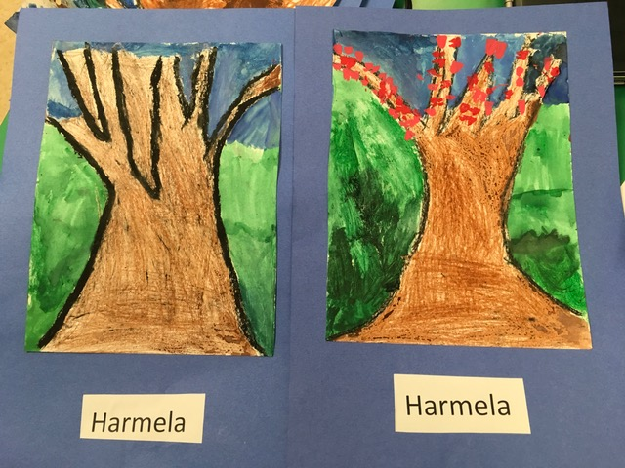**Visual Arts and Science Infused Lesson**

***Changing Trees***

Authors: Colleen Farrell with Carol Gould Grade Level: Kindergarten

**Enduring Understanding**

Shape, line, color, and texture can be used to show seasonal change in trees.

**Lesson Description (Use for family communication and displaying student art)**

*Students learn about how they can sketch the shape and growth pattern of a tree by looking at art examples and practicing drawing. Next, they create a resist effect using oil pastels and watercolor in compositions that show the change from a Winter tree to a Spring tree.*

**Learning Targets and Assessment Criteria**

**Target:** Creates two drawings to show change.

**Criteria:** Draws tree twice adding color and texture that describe Winter and Spring.

**Target:** Creates a resist effect.

**Criteria:** Washes over carefully colored pastel tree with watercolor.

**Target:** Demonstrates the 21st century skill of perseverance.

**Criteria:** Persists in adapting ideas to work through challenges.

**Vocabulary**

Arts infused:

Color

Observe

Pattern

Shape

Texture

Science:

Bark

Branches

Buds

Change

Cycle

Deciduous

Dormant

Evergreen

Growth

Leaves

Limbs

Orchard

Seasons

Variety

Arts:

Background

Open composition

Pastel resist

Watercolor wash

**Materials**

**Museum Artworks or Performance**

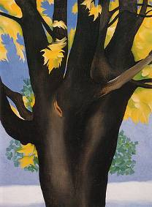 

*Black Maple Trunk Yellow Leaves,*

Georgia O’Keeffe 1929

**TAM:** Ambrose Patterson

*Monterey Cypress Trees*

*An Apple Tree through the Year* by Claudia Schnieper pg 35 and 37

**Materials**

Wooden spoons or Popsicle sticks

Bark

Whiteboards and dry erase markers

Oil pastels

Water Colors

Water Color Brushes

Art pencils

Erasers

Newsprint

11 x 14 drawing paper

**Learning Standards**

**WA Arts State Grade Level Expectations**

*For the full description of each WA State Arts Grade Level Expectation, see:* [*http://www.k12.wa.us/Arts/Standards*](http://www.k12.wa.us/Arts/Standards)

1.1.1 Elements: Line

1.1.2. Elements: Shape/Form

1.1.4. Elements: Texture

1.1.6 Elements: Color

1.1.7 Principles of Design: Repetition

1.2.1 Skills and Techniques: Watercolor resist

2.1.1 Creative Process

2.3.1 Responding Process

4.2.1 Connection between Visual Art and Science

**Early Learning Guidelines, if applicable**

*For a full description of Washington State Early Learning and Child Development Guidelines see: http://www.k12.wa.us/EarlyLearning/guidelines.aspx*

(Age 4-5) 6. Learning about my world: Science: Talk about changes in the weather and seasons, using common words, such as rainy and windy.

(Age 5 and Kindergarten) 6. Learning about my World: Science: Make observations and ask questions. Identify ways to find answers. Try out these activities and think about what to do next to learn more. Arts: Learn ways to create artwork.

*continued*

**Next Generation Science Standards**

[*http://www.nextgenscience.org/next-generation-science-standards*](http://www.nextgenscience.org/next-generation-science-standards)

***This is related to the K Foss Science kit on Wood***

**Performance Expectations**

K-LS1-1 Use observations to describe patterns of what plants and animals (including humans) need to survive.

K-ESS2-1 Use and share observations of local weather conditions to describe patterns over time.

1.ESS1-1 Use observation of the sun, moon and stars to describe patterns that can be predicted.

1.ESS1-2 Make observations at different times of year to relate the amount of daylight to the time of year.

**Science and Engineering Practices**

2. Developing and Using Models

4. Analyzing and Interpreting Data

8. Obtaining, Evaluating, and Communicating Information

**Disciplinary Core Ideas**

LS1.A: Structure and Function

LS1.B: Growth and Development of Organisms

**Crosscutting Concepts**

Patterns

Stability and change

Structure and function

Cause and Effect

**Pre-Teach**

**ICON KEY:**

🗏 = Indicates note or reminder for teacher

🗹 = Embedded assessment points in the lesson

Show *An Apple Tree through the Year* highlighting the Winter and Spring picture changes on page 37 and 35. Talk about how it takes perseverance to draw trees. *All trees look different just like us but all are special! We are all learning together and we can encourage each other with positive and kind words. We need to be kind to ourselves, try our best, and not give up.*

**Lesson Steps Outline**

**1.** Introduce concept of tree shape. Show students art example (O’Keeffe).

🗹 Criteria-based process assessment: Makes tree shapes with body, observes real textures, responds to art.

**2.** Brainstorm differences between Winter and Spring trees and watch teacher demo of basic tree drawing strategy. Show Ambrose Patterson *Monterey Cypress Trees*.

🗹 Criteria-based process assessment: Observes demonstration, observes and responds to art, practices drawing trees on whiteboard and paper.

**3.** Emphasize perseverance. Guide students as they draw tree with pencil using V shapes and an open composition. Students go over tree pencil line with

black pastel, fold paper and rub with wooden spoons—therefore transferring

the drawing.

🗹 Criteria-based teacher checklist: Draws tree twice. Persists in adapting ideas to work through challenges.

**4.** Guide students as they add color and texture to their trees to show Winter and Spring using oil pastels. Remind students about tree science words listed in vocabulary: buds, leaves, branches.

🗹 Criteria-based teacher checklist: Draws tree twice adding color and texture that describe Winter and Spring. Persists in adapting ideas to work through challenges.

**5.** Demonstrate and guide watercolor resist process. Students use watercolor wash to create the background for their Winter and Spring tree collection.

🗹 Criteria-based teacher checklist: Washes over carefully colored pastel tree with watercolor.

**6.** Display student trees to create a forest walk: Focus on the variety, differences, and similarities. Guide reflection on perseverance.

🗹 Criteria-based peer reflection: Notices similarities and differences in peer’s artwork, thinks and shares about perseverance.

**LESSON STEPS____________________________________________**

**1. Introduce concept of tree shape.**

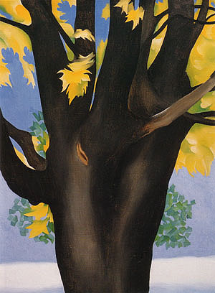

* *Friends, lets stand up and reach for the sky as we make our body into the shape of a tree. Blow into the wind. Our arms will be the limbs and our legs will be the tree trunk. Freeze your tree.*
* *Friends have a seat in your rug spot.*

*Let’s look at how artists look at tree shapes.*

**Show students art example.**

🗏 Project images of artwork on screen.

* *Notice how this artist, Georgia O’Keeffe used different brown colors to show the texture of the tree. (texture means how something feels)*
* *I’m passing around a piece of bark from a tree. Bark is like the tree’s skin. Feel the texture.*
* *What else do you see in this painting? What*

*season do you think this is and why?*

* *Today we will be learning how to draw trees together. We will draw the same tree twice to show the change. We will draw the same tree in Winter and Spring.*

🗹 Criteria-based process assessment: Makes tree shapes with body, observes real textures, responds to art.

**_______________________________________________________________________**

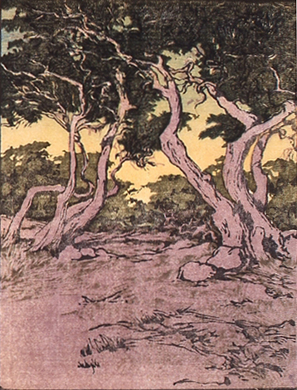

**2.** **Brainstorm differences between Winter and Spring trees and watch teacher demo of basic tree drawing strategy. Show Ambrose Patterson *Monterey Cypress Trees*.**

* *Let’s think of what a tree looks like in the Winter and Spring.*

🗏 Teacher writes notes as students share out similarities and differences on a chart.

* *Now watch me as I begin drawing my tree with a line going up just as my arm did when I was frozen as the tree. I am making V shapes to make the branches and limbs of my tree. Notice they are the shape of the letter V.*
* *Notice the Vs in* Monterey Cypress Trees.
* *How are these tree pictures similar? Do we see all of the trees? (They are open compositions.)*
* *Now let’s practice together making our own V’s on whiteboards and then our practice paper. Don’t worry about making mistakes. We are all learning together and having fun making trees.*

🗹 Criteria-based process assessment: Observes demonstration, observes and responds to art, practices drawing trees on whiteboard and paper.

**_______________________________________________________________________**

**3. Emphasize perseverance. Guide students as they draw tree with pencil using V shapes and an open composition. Students go over tree pencil line with black pastel, fold paper and rub with wooden spoons-therefore transferring the drawing.**

🗏 Adaptations: Cut out folded tree to make two or fold or cut one tree in half.

* *Think about perseverance as you work: It means working through challenges or problems and not giving up.*
* *Begin on one side. Make sure to use Vs. Extend the branches out.*

🗹 Criteria-based teacher checklist: Draws tree twice. Persists in adapting ideas to work through challenges.

**_______________________________________________________________________**

**4. Guide students as they add color and texture to their trees to show Winter and Spring using oil pastels. Remind students about tree science words listed in vocabulary: buds, leaves, branches.**

🗏 Crayons are an option if oil pastels are unavailable.

* *Press firmly for bright color. Look at the bark—how did it feel? Show the bark texture on*

*your trees!*

🗹 Criteria-based teacher checklist: Draws tree twice adding color and texture that describe Winter and Spring. Persists in adapting ideas to work through challenges.

**_______________________________________________________________________**

**5. Demonstrate and guide watercolor resist process. Students use watercolor wash to create the background for their Winter and Spring tree collection.**

* *Notice as I thoughtfully choose a color for the background.*
* *Add water to paint.*
* *Keep trays tidy: do not mix on top of pans of color.*

🗹 Criteria-based teacher checklist: Washes over carefully colored pastel tree with watercolor.

**_______________________________________________________________________**

**6. Display student trees to create a forest walk: Focus on the variety, differences, and similarities. Guide reflection on perseverance.**

🗏 Refer back to Day One’s pre-teach.

* *All trees look different just like us: We are all are special!*
* *What do you notice in a friend’s artwork?*
* *What is the same in our forest? What is different in our forest?*
* *When did you use perseverance to create your trees? Perseverance means trying your best and not giving up.*

🗹 Criteria-based peer reflection: Notices similarities and differences in peer’s artwork, thinks and shares about perseverance.

**_______________________________________________________________________**

**ARTS IMPACT LESSON PLAN Visual Arts and Science Infused Lesson**

Kindergarten: *Changing Trees*

**CLASS ASSESSMENT WORKSHEET**

|  |  |  |  |  |  |
| --- | --- | --- | --- | --- | --- |
| Disciplines | **VISUAL ARTS and SCIENCE** | | **VISUAL ARTS** | | Total  4 |
| Concept | Observation and Change | | Resist Technique | 21st Century Skills |
| Criteria  Student Name | Draws tree twice. | Adds color and texture that describe Winter and Spring. | Washes over carefully colored pastel tree with watercolor. | Persists in adapting ideas to work through challenges. |
| 1. |  |  |  |  |  |
| 2. |  |  |  |  |  |
| 3. |  |  |  |  |  |
| 4. |  |  |  |  |  |
| 5. |  |  |  |  |  |
| 6. |  |  |  |  |  |
| 7. |  |  |  |  |  |
| 8. |  |  |  |  |  |
| 9. |  |  |  |  |  |
| 10. |  |  |  |  |  |
| 11. |  |  |  |  |  |
| 12. |  |  |  |  |  |
| 13. |  |  |  |  |  |
| 14. |  |  |  |  |  |
| 15. |  |  |  |  |  |
| 16. |  |  |  |  |  |
| 17. |  |  |  |  |  |
| 18. |  |  |  |  |  |
| 19. |  |  |  |  |  |
| 20. |  |  |  |  |  |
| 21. |  |  |  |  |  |
| 22. |  |  |  |  |  |
| 23. |  |  |  |  |  |
| 24. |  |  |  |  |  |
| 25. |  |  |  |  |  |
| 26. |  |  |  |  |  |
| 27. |  |  |  |  |  |
| 28. |  |  |  |  |  |
| 29. |  |  |  |  |  |
| 30. |  |  |  |  |  |
| Total |  |  |  |  |  |
| Percentage |  |  |  |  |  |

*What was effective in the lesson? Why?*

*What do I want to consider for the next time I teach this lesson?*

*What were the strongest connections between arts discipline and subject area?*

Teacher: Date:

**ARTS IMPACT FAMILY LETTER**

ARTS AND SCIENCE LESSON: ***Changing Trees***

Dear Family:

Today your child participated in a **Visual Arts** and **Science** Infused lesson. We talked about trees we saw in artwork.

* We discovered how we can sketch the shape and growth pattern of a tree.
* We practiced drawing trees.
* We created a resist effect using oil pastels and watercolor.
* We showed the change from a Winter tree to a Spring tree in our compositions.

At home, you could study and draw trees in your neighborhood throughout the seasons.

**Enduring Understanding**

Shape, line, color, and texture can be used to show seasonal change in trees.