**ARTS IMPACT LESSON PLAN**

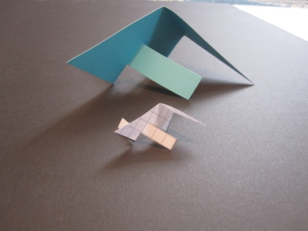**Visual Arts and Math Infused Lesson**

**Lesson Two: *Scaling Up Shapes for Sculpture***

Author: Meredith Essex Grade Level: Eighth

**Enduring Understanding**

Ratio and proportional relationships guide design of scale models and fabrication of full-sized sculpture.

**Lesson Description (Use for family communication and displaying student art)**

*Students analyze proportional relationships of elements in art. Students graph a small-scale right triangle for a design model on the coordinate plane then enlarge it to graph a similar right triangle which becomes a pattern for the final sculpture. The design model and pattern are then cut out, and the larger pattern is traced on heavy colorful paper. The model triangle is transformed from 2-D to 3-D through cutting and folding. Last, the final sculpture is created through replicating the same 2-D to 3-D process on a larger scale.*

**Learning Targets and Assessment Criteria**

**Target:** Identifies similar figures in art.

**Criteria:** Describes proportional relationships of geometric shapes/forms seen in art.

**Target:** Shows a proportional relationship.

**Criteria:** Graphs similar right triangles on the coordinate plane.

**Target:** Uses proportional reasoning to plan a sculpture.

**Criteria:** Uses coordinates and scale factor to graph a small right triangle as a sculpture design model and a larger similar right triangle paper sculpture pattern.

**Target:** Uses craftsmanship in making paper shapes.

**Criteria:** Smoothly and accurately cuts: enlarged triangle pattern drawn on coordinate plane, enlarged triangle shape on cardstock (after tracing pattern), and small triangle design model on coordinate plane.

**Target:** Creates design model and enlarged paper sculpture.

**Criteria:** Measures, cuts (without cutting apart) and folds 2-D design model triangle shape into a

3-D form. Uses measurement and scale factor to proportionally cut and fold enlarged triangle shape

into a 3-D form based on design model.

**Vocabulary**

Arts Infused:

2-Dimensional

3-Dimensional

Geometric Shape

Grid

Model

Plane

Proportion

Ratio

Scale

Math:

Coordinate Plane

Coordinates

Origin

Right Triangle

Scale Factor

Similar Figures

Slope

Vertex

Vertices

X-axis

Y-axis

Arts:

Craftsmanship

Design

Sculpture

**Learning Standards**

**WA Arts State Grade Level Expectations**

*For the full description of each WA State Arts Grade Level Expectation, see:* [*http://www.k12.wa.us/Arts/Standards*](http://www.k12.wa.us/Arts/Standards)

1.1.2 Elements: Shape

1.1.7 Principles of Design: Proportion

1.2.1 Skills and Techniques: Drawing, Paper Sculpture

2.1.1 Creative Process

2.2.1 Presentation Process

2.3.1 Responding Process

4.2.1 Connection between Visual Arts and Math

**Common Core State Standards (CCSS) in Math** For a full description of CCSS Standards by grade level see:[*http://www.k12.wa.us/CoreStandards/Mathematics/Standards/*](http://www.k12.wa.us/CoreStandards/Mathematics/Standards/)*default.aspx*

8.EE. Understand the connections between proportional relationships, lines and linear equations.

8.EE.6. Use similar triangles to explain why the slope *m* is the same between any distinct points on a non-vertical line in the coordinate plane; derive the equation *y=mx+b* for a line intercepting the vertical axis at *b.*

**CCSS Mathematical Practices**

MP.4. Model with mathematics.

MP.5. Use appropriate tools strategically.

MP.6. Attend to precision.

**Materials**

**Museum Artworks or Performance**

### Seattle, WA

Seattle Art Museum

### Tacoma, WA

Tacoma Art Museum

**Materials**

Drawing pencil: 4H; Vinyl eraser; Arts Impact sketchbook; White copy paper: 8.5x11”; copy Coordinate Plane worksheet from lesson: two per student; Cardstock: 8.5x11”, two-colored (front and back different color), one per student; Scissors; Protractors; Rulers; Class Assessment Worksheet

Seattle Art Museum images:

*The Middle West*, 1929, Mark Tobey, 42.20

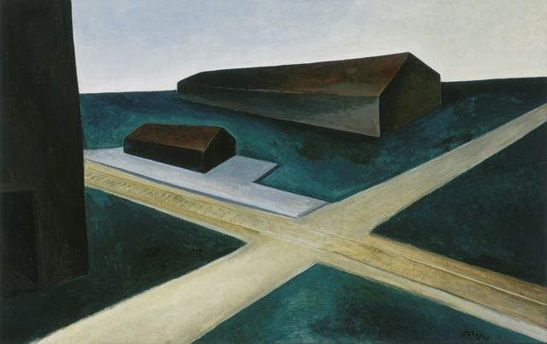

*Gray Point*, 1981, Robert Maki, 82.68

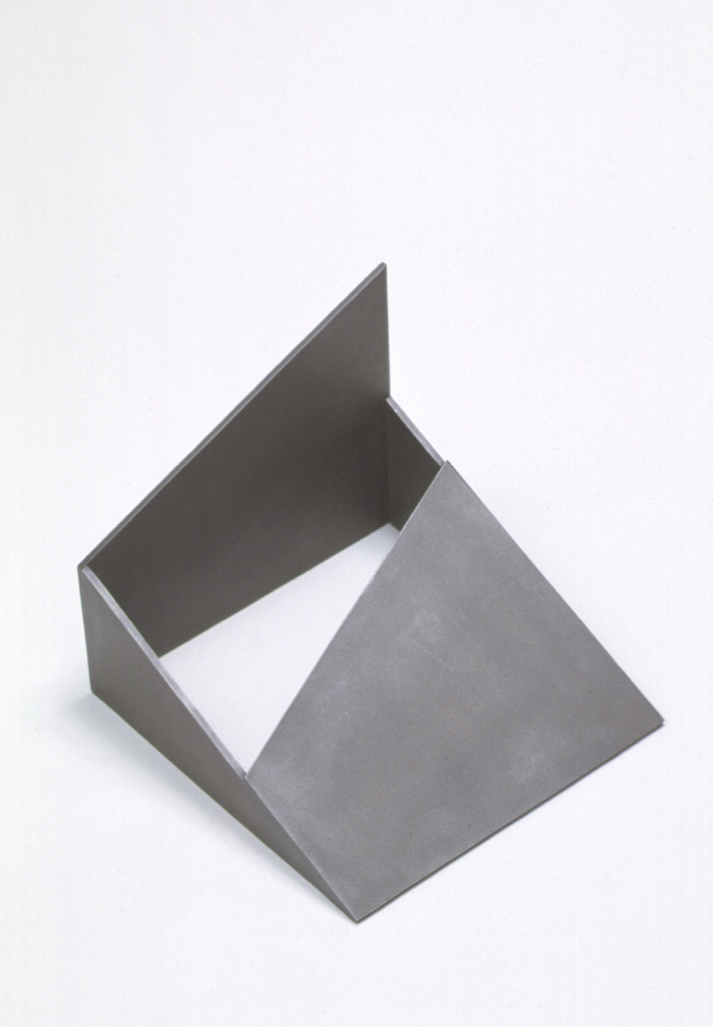

**ICON KEY:**

🗏 = Indicates note or reminder for teacher

🗹 =Embedded assessment points in the lesson

**Pre-Teach**

Ask students to search for and share examples of objects or images that represent a scale or ratio relationship: toy models, images on electronic devices. Discuss the practical need for designing small for building large and how using ratio and scale factor plays into calculating needs for fabricating a large three-dimensional work of art or other kinds of large constructions.

**Lesson Steps Outline**

**1.** Introduce and guide art analysis of *The Middle West* by Mark Tobey from the Seattle Art Museum collection. Focus on scale relationships, similar figures/shapes, and the process of planning and creating sculpture.

🗹 Criteria-based peer assessment and teacher checklist: Describes proportional relationships of geometric shapes/forms seen in art.

**2.** Guide practice exercise graphing a right triangle on the coordinate plane. Guide graphing a similar larger triangle and noting conclusions about slope and proportional relationships.

🗹 Criteria-based peer assessment and teacher checklist: Graphs similar right triangles on the coordinate plane.

**3.** Facilitate discussion of scale models and how important they are in design and fabrication of large-scale sculpture.

**4.** Guide students in graphing similar right triangles on the coordinate plane using craftsmanship, then cutting the entire larger triangle out. The smaller will become a small-scale design model, and the larger will become a pattern traced on cardstock, cut out, and used for the final enlarged sculpture.

🗹 Criteria-based teacher checklist: Uses coordinates and scale factor to graph a small right triangle as a sculpture design model, and a larger similar right triangle paper sculpture pattern. Smoothly and accurately cuts enlarged triangle pattern drawn on coordinate plane.

**5.** Introduce and guide art analysis of the sculpture *Gray Point* by Robert Maki from the Seattle Art Museum collection. Note that the sculpture is composed of basically 2-dimensional flat planes, yet appears to definitely be 3-dimensional.

**6.** Demonstrate and guide tracing pattern for larger triangle on cardstock of choice. After tracing the large triangle, directs student to cut out the small triangle that is “inside” the pattern.

Demonstrate strategically using measurement to mark, cut and fold (without cutting shape apart) small-scale triangle (model) into a 3-dimensional form. The scale design model is then used as a guide to mark, cut, and fold the final enlarged sculpture proportionally.

🗹 Criteria-based teacher checklist: Smoothly and accurately cuts: enlarged triangle shape on cardstock (after tracing pattern), and small triangle design model on coordinate plane. Measures, cuts (without cutting apart) and folds 2-D design model triangle shape into a 3-D form. Uses measurement and scale factor to proportionally cut and fold enlarged triangle shape into a 3-D form based on design model.

**7.** Facilitate criteria-based peer and group math and art reflection.

🗹 Criteria-based peer assessment and group reflection: Compares scale models with finished sculptures, reflects on artistic and mathematical challenges, and explores interaction of sculptures in space.

**LESSON STEPS____________________________________________**

**1. Introduce and guide art analysis of *The Middle West* by Mark Tobey from the Seattle Art Museum collection. Guide math and art analysis with focus on scale relationships, similar figures/shapes, and the process of planning and creating sculpture.**



🗏 The Seattle Art Museum’s collection is available on-line at: <http://www.seattleartmuseum.org/emuseum/code/collection.asp>. To find the images in this lesson, enter the accession number for the work of art in the search box on the collections page of SAM’s website. Accession numbers for these works of art are listed in the materials box at the beginning of

the lesson.

* *Notice the small and large buildings in Mark Tobey’s painting. Are they of the same proportion?*

*Are there similar shapes?*

* *In looking at a 3-dimensional work, Beverly Pepper’s sculpture, where do you see*

*similar figures?*

* *Talk about these two works of art with a partner. Use your knowledge of math, estimation and geometry to identify whether they are composed of similar figures/shapes. What could be a math strategy for figuring that out?*
* *What do you notice? Share you and your partner’s conclusions and the thinking/discussion that led to that conclusion.*

🗹 Criteria-based peer assessment and teacher checklist: Describes proportional relationships of geometric shapes/forms seen in art.

**______________________________________________________________________**

**2. Guide practice exercise graphing a right triangle on the coordinate plane.**

**Guide graphing a similar larger triangle and noting conclusions about slope and proportional relationships.**

🗏 This step can be differentiated and simplified by assigning specific coordinates for *B* and

*C* vertices, then asking students as a group to use the same factor to identify coordinates

*C*

for and graph a similar triangle.

* *Using the coordinate plane, graph a small right triangle with one vertex (A)*

*at the origin, a second vertex (B) on the x-axis, and the third vertex (C)*

*B*

*A*

*placed on a line parallel with the y-axis.*

* *Using a scale factor, calculate the length of sides of a similar, larger triangle (ADE), and graph it in the same quadrant (also using the origin/A as a vertex.)*
* *What do you notice about the relationship of the two triangles? (rate of slope is the same)*

🗹 Criteria-based peer assessment and teacher checklist: Graphs similar right triangles on the coordinate plane.

**_______________________________________________________________________**

**3. Facilitate discussion of scale models and how important they are in design and fabrication of large-scale sculpture.**

* *Why would an artist or designer build something small before constructing it on a larger scale?*
* *What math concepts might be important in the process of designing and fabricating a work of art? (measuring, proportion, ratio…)*
* *We are going to work with the process of using proportional reasoning to create a small-scale design model for a sculpture and a slightly larger finished sculpture. Both model and sculpture will be constructed from similar right triangles.*

**_______________________________________________________________________**

**4. Guide students in graphing similar right triangles on the coordinate plane using craftsmanship, then cutting the entire larger triangle out. The smaller will become a small-scale design model, and the larger will become a pattern traced on cardstock, cut out, and used for the final enlarged sculpture.**

* *Using the same process we practiced earlier, graph a right triangle (ABC).*
* *Now graph a larger similar right triangle (ADE).*
* *The small triangle on grid paper (ABC) will be your scale design model for a paper sculpture. The large triangle (ADE) on grid paper becomes a pattern for cutting out your sculpture shape out of cardstock: Cut the larger triangle out. Use craftsmanship: care and attention to mathematical precision in measuring and cutting.*

🗹 Criteria-based teacher checklist: Uses coordinates and scale factor to graph a small right triangle as a sculpture design model, and a larger similar right triangle paper sculpture pattern. Smoothly and accurately cuts enlarged triangle pattern drawn on coordinate plane.

**_______________________________________________________________________**

**5.** **Introduce and guide art analysis of the sculpture *Gray Point* by Robert Maki from the Seattle Art Museum collection. Note that the sculpture is composed of basically 2-dimensional flat planes, yet appears to definitely be 3-dimensional.**



* *Sometimes sculptures are created out of flat, seemingly 2-dimensional materials. Often they are metal sheets that have been altered to become 3-dimensional sculptural forms.*
* *Our paper sculpture scale design model and final work are similar because they are flat to start with and will be altered by cutting and folding to become 3-dimensional forms.*

**_______________________________________________________________________**

**6.** **Demonstrate and guide tracing pattern for larger triangle on cardstock of choice. After tracing the large triangle, directs student to cut out the small triangle that is “inside”**

**the pattern.**

* *Select a color and size of cardstock that works with your pattern size.*
* *Trace around your larger similar triangle pattern on cardstock. Line up the corner of the triangle with a corner of the paper for minimal waste.*
* *Now, cut out your little small-scale triangle that is part of the larger triangle pattern on the coordinate plane.*

**Demonstrate strategically using measurement to mark, cut and fold (without cutting shape apart) small-scale triangle (model) into a 3-dimensional form. The scale**

**design model is then used as a guide to mark, cut, and fold the final enlarged**

**sculpture proportionally.**

* *We want to be strategic. We will transform the design model into a 3-dimensional form by cutting and folding (but not cutting the shape completely apart) and then use it as a guide for our final sculpture.*
* *Measure and mark where you will cut and where you will fold on the small design model triangle. Know that you will be creating the same alterations to the large triangle, but on a larger proportional scale.*
* *You can use your grid paper pattern (for cutting out the large triangle) to help figure out how to proportionally measure, mark, cut and fold your larger sculpture shape.*
* *Fold and cut precisely!*

🗹 Criteria-based teacher checklist: Smoothly and accurately cuts: enlarged triangle shape on cardstock (after tracing pattern), and small triangle design model on coordinate plane. Measures, cuts (without cutting apart) and folds 2-D design model triangle shape into a 3-D form. Uses measurement and scale factor to proportionally cut and fold enlarged triangle shape into a 3-D form based on design model.

**_______________________________________________________________________**

**7.** **Facilitate criteria-based peer and group math and art reflection.**

🗏 Cover a large table with black paper to enhance presentation and have students arrange their models with their finished sculptures into a kind of miniature sculpture park (like SAM’s Olympic Sculpture Park).

* *Place your scale model next to your final paper sculpture within a miniature class*

*“sculpture park”.*

* *Compare models and finished sculptures. How accurately did the artist reproduce design model shapes and relationships in the larger scale final sculpture?*
* *Describe the challenges of creating your sculpture proportionally based on your design model.*
* *How does your perception of the sculpture change when sculptures are placed in relation to*

*one another?*

🗹 Criteria-based peer assessment and group reflection: Compares scale models with finished sculptures, reflects on artistic and mathematical challenges, and explores interaction of sculptures in space.

**_______________________________________________________________________**

***Scaling Up Shapes for Sculpture* Coordinate Plane Worksheet**

ArtsImpact:Sibyl:Curriculum:Arts Infused Curriculum:Math:Middle School Curriculum:Visual Arts:3 from Meredith:3 8th Grade:G8#2ScalingupShapesCoordinatePlane.pdf

Name: Date:

**ARTS IMPACT LESSON PLAN Visual Arts and Math Infusion**

Eighth GradeLesson Two: ***Scaling Up Shapes for Sculpture***

🗏 Teachers may choose to use or adapt the following self-assessment tool.

**STUDENT SELF-ASSESSMENT WORKSHEET**

|  |  |  |  |  |  |  |  |
| --- | --- | --- | --- | --- | --- | --- | --- |
| Disciplines | **VISUAL ARTS AND MATH** | | | | | | Total  6 |
| Concept | Ratio and Proportion | | | **Craftsmanship/Ratio/Proportion** | | |
| Criteria  Student Name | Describes proportional relationships of geometric shapes seen in art. | Graphs similar right triangles on the coordinate plane. | Uses coordinates and scale factor to graph a small right triangle and a larger similar right triangle (for model and pattern). | Smoothly and accurately cuts: enlarged triangle pattern on coordinate plane, enlarged triangle shape on cardstock (after tracing pattern), and small triangle design model on coordinate plane. | Measures, cuts and folds 2-D design model triangle shape into a 3-D form. | Uses measurement and scale factor to proportionally cut and fold enlarged triangle shape into a 3-D form based on design model. |
|  |  |  |  |  |  |  |  |

**ARTS IMPACT LESSON PLAN Visual Arts and Math Infusion**

Eighth GradeLesson Two: ***Scaling Up Shapes for Sculpture***

**CLASS ASSESSMENT WORKSHEET**

|  |  |  |  |  |  |  |  |
| --- | --- | --- | --- | --- | --- | --- | --- |
| Disciplines | **VISUAL ARTS AND MATH** | | | | | | Total  6 |
| Concept | Ratio and Proportion | | | Craftsmanship/Ratio/Proportion | | |
| Criteria  Student Name | Describes proportional relationships of geometric shapes seen in art. | Graphs similar right triangles on the coordinate plane. | Uses coordinates and scale factor to graph a small right triangle and a larger similar right triangle (for model and pattern). | Smoothly and accurately cuts: enlarged triangle pattern on coordinate plane, enlarged triangle shape on cardstock (after tracing pattern), and small triangle design model on coordinate plane. | Measures, cuts and folds 2-D design model triangle shape into a 3-D form. | Uses measurement and scale factor to proportionally cut and fold enlarged triangle shape into a 3-D form based on design model. |
| 1. |  |  |  |  |  |  |  |
| 2. |  |  |  |  |  |  |  |
| 3. |  |  |  |  |  |  |  |
| 4. |  |  |  |  |  |  |  |
| 5. |  |  |  |  |  |  |  |
| 6. |  |  |  |  |  |  |  |
| 7. |  |  |  |  |  |  |  |
| 8. |  |  |  |  |  |  |  |
| 9. |  |  |  |  |  |  |  |
| 10. |  |  |  |  |  |  |  |
| 11. |  |  |  |  |  |  |  |
| 12. |  |  |  |  |  |  |  |
| 13. |  |  |  |  |  |  |  |
| 14. |  |  |  |  |  |  |  |
| 15. |  |  |  |  |  |  |  |
| 16. |  |  |  |  |  |  |  |
| 17. |  |  |  |  |  |  |  |
| 18. |  |  |  |  |  |  |  |
| 19. |  |  |  |  |  |  |  |
| 20. |  |  |  |  |  |  |  |
| 21. |  |  |  |  |  |  |  |
| 22. |  |  |  |  |  |  |  |
| 23. |  |  |  |  |  |  |  |
| 24. |  |  |  |  |  |  |  |
| 25. |  |  |  |  |  |  |  |
| 26. |  |  |  |  |  |  |  |
| 27. |  |  |  |  |  |  |  |
| 28. |  |  |  |  |  |  |  |
| 29. |  |  |  |  |  |  |  |
| 30. |  |  |  |  |  |  |  |
| Total |  |  |  |  |  |  |  |
| Percentage |  |  |  |  |  |  |  |

*What was effective in the lesson? Why?*

*What do I want to consider for the next time I teach this lesson?*

*What were the strongest connections between visual arts and math?*

Teacher: Date:

**ARTS IMPACT FAMILY LETTER**

VISUAL ARTS AND MATH LESSON: ***Scaling Up Shapes for Sculpture***

Dear Family:

Today your child participated in an **Arts and Math** lesson. We analyzed proportional relationships of elements in seen in art. We talked about the math concepts of ratio, scale, and similar figures and how they relate to art.

* We practiced graphing similar right triangles on the coordinate plane. We started by graphing a small right triangle, then multiplied its three sides by a scale factor to enlarge it. We noticed that the slope of our similar triangles remained constant.
* We graphed similar triangles again, this time for the purpose of creating a small scale design model for a paper sculpture and a final larger size paper sculpture with the same proportions.
* We cut out our large triangle that we graphed on the coordinate plane and used it as a pattern. We traced around our pattern on colorful heavy paper and carefully cut it out.
* We also cut out our first small triangle that shares the same proportions and slope as our large triangle (drawn in the corner of the larger triangle).
* We transformed the small triangle into a small-scale model. We changed it from 2-D to 3-D through measuring, cutting, and folding without cutting the shape completely apart.
* We created our final sculpture using our large triangle cut from heavy paper. We replicated the same 2-D to 3-D cutting and folding process that we used in our design model on a

larger scale.

At home, you could create scale models of sculpture ideas from cardboard, heavy papers, or other found materials, then build them on a much larger scale. You could also play with the idea of constructing something very large and then building a scaled-down version of it in miniature.

**Enduring Understanding**

Ratio and proportional relationships guide design of scale models and fabrication of full-sized sculpture.